Spring common interview questions

Questions:-how to write custom Exception Handler and error.html page for Whitelabel Error Page
Answer: - https://www.baeldung.com/spring-boot-custom-error-page

Spring boot webclient smple code example GET PUT POST DELETE

Setup
To use WebClient, ensure you have the following dependency in your pom.xml:

<dependency>
<groupId>org.springframework.boot</groupId>
<artifactId>spring-boot-starter-webflux</artifactId>
</dependency>

GET Request
import org.springframework.web.reactive.function.client.WebClient;
import reactor.core.publisher.Mono;

public class WebClientExample {

private final WebClient webClient;

public WebClientExample(WebClient.Builder webClientBuilder) {
this.webClient = webClientBuilder.baseUrl("https://jsonplaceholder.typicode.com").build();
}

public Mono<String> getPostById(Long postId) {
return webClient.get()
.uri("/posts/{id}", postId)
.retrieve()
.bodyToMono(String.class);
}
}

POST Request
import org.springframework.web.reactive.function.client.WebClient;
import reactor.core.publisher.Mono;

public class WebClientExample {

public Mono<String> createPost(Post post) {
return webClient.post()
.uri("/posts")
.body(Mono.just(post), Post.class)
.retrieve()
.bodyToMono(String.class);
}
}

class Post {
private Long userId;
private String title;
private String body;

// Getters and setters
}
PUT Request
public Mono<String> updatePost(Long postId, Post updatedPost) {
return webClient.put()
.uri("/posts/{id}", postId)
.body(Mono.just(updatedPost), Post.class)
.retrieve()
.bodyToMono(String.class);
}
DELETE Request
public Mono<Void> deletePost(Long postId) {
return webClient.delete()
.uri("/posts/{id}", postId)
.retrieve()
.bodyToMono(Void.class);
}
Usage Example
public static void main(String[] args) {
WebClientExample example = new WebClientExample(WebClient.builder());
example.getPostById(1L).subscribe(System.out::println);

Post newPost = new Post();
newPost.setUserId(1L);
newPost.setTitle("New Post Title");
newPost.setBody("This is the body of the new post.");
example.createPost(newPost).subscribe(System.out::println);

Post updatedPost = new Post();
updatedPost.setUserId(1L);
updatedPost.setTitle("Updated Title");
updatedPost.setBody("Updated body content.");
example.updatePost(1L, updatedPost).subscribe(System.out::println);

example.deletePost(1L).subscribe();
}
Each of these methods returns a Mono, which allows for asynchronous, non-blocking execution of HTTP requests. Adjust the base URL and uri paths as needed for your API.

Resttemplate exchange GET PUT POST DELETE code sample

Here are examples of how to use RestTemplate in Spring Boot to perform GET, POST, PUT, and DELETE requests using the exchange method.

Setup
To use RestTemplate, add the following dependency in your pom.xml if it's not already there:

<dependency>
<groupId>org.springframework.boot</groupId>
<artifactId>spring-boot-starter-web</artifactId>
</dependency>
Example Service Class with RestTemplate
import org.springframework.http.HttpEntity;
import org.springframework.http.HttpHeaders;
import org.springframework.http.HttpMethod;
import org.springframework.http.ResponseEntity;
import org.springframework.stereotype.Service;
import org.springframework.web.client.RestTemplate;

@Service
public class RestTemplateExample {

private final RestTemplate restTemplate;

public RestTemplateExample(RestTemplate restTemplate) {
this.restTemplate = restTemplate;
}

private static final String BASE_URL = "https://jsonplaceholder.typicode.com";

// GET Request
public String getPostById(Long postId) {
String url = BASE_URL + "/posts/" + postId;
ResponseEntity<String> response = restTemplate.exchange(url, HttpMethod.GET, null, String.class);
return response.getBody();
}

// POST Request
public String createPost(Post post) {
String url = BASE_URL + "/posts";
HttpEntity<Post> request = new HttpEntity<>(post);
ResponseEntity<String> response = restTemplate.exchange(url, HttpMethod.POST, request, String.class);
return response.getBody();
}

// PUT Request
public String updatePost(Long postId, Post updatedPost) {
String url = BASE_URL + "/posts/" + postId;
HttpEntity<Post> request = new HttpEntity<>(updatedPost);
ResponseEntity<String> response = restTemplate.exchange(url, HttpMethod.PUT, request, String.class);
return response.getBody();
}

// DELETE Request
public void deletePost(Long postId) {
String url = BASE_URL + "/posts/" + postId;
restTemplate.exchange(url, HttpMethod.DELETE, null, Void.class);
}
}
Post Class
public class Post {
private Long userId;
private String title;
private String body;

// Getters and Setters
}
Usage Example
import org.springframework.boot.CommandLineRunner;
import org.springframework.stereotype.Component;

@Component
public class RestTemplateExampleRunner implements CommandLineRunner {

private final RestTemplateExample restTemplateExample;

public RestTemplateExampleRunner(RestTemplateExample restTemplateExample) {
this.restTemplateExample = restTemplateExample;
}

@Override
public void run(String... args) {
// GET
System.out.println("GET Request:");
System.out.println(restTemplateExample.getPostById(1L));

// POST
System.out.println("POST Request:");
Post newPost = new Post();
newPost.setUserId(1L);
newPost.setTitle("New Post Title");
newPost.setBody("This is the body of the new post.");
System.out.println(restTemplateExample.createPost(newPost));

// PUT
System.out.println("PUT Request:");
Post updatedPost = new Post();
updatedPost.setUserId(1L);
updatedPost.setTitle("Updated Title");
updatedPost.setBody("Updated body content.");
System.out.println(restTemplateExample.updatePost(1L, updatedPost));

// DELETE
System.out.println("DELETE Request:");
restTemplateExample.deletePost(1L);
System.out.println("Post deleted.");
}
}
Explanation
GET Request: Retrieves a resource. The exchange method is called with HttpMethod.GET.
POST Request: Creates a new resource. The exchange method is called with HttpMethod.POST.
PUT Request: Updates an existing resource. The exchange method is called with HttpMethod.PUT.
DELETE Request: Deletes a resource. The exchange method is called with HttpMethod.DELETE.
This example uses RestTemplate for synchronous requests; adjust the URL, headers, and payloads as per your API requirements.
You said:
What is the difference between RestTemplate nd WebClient
ChatGPT said:
RestTemplate and WebClient are both tools used in Spring to interact with RESTful web services, but they differ in how they are implemented, their use cases, and their features. Here's a breakdown of their differences:

1. Synchronous vs. Asynchronous
RestTemplate: It is synchronous, meaning each HTTP request blocks the thread until the response is received. This can lead to inefficiency when working with high-concurrency applications because each request occupies a thread until completion.

WebClient: It is non-blocking and asynchronous, based on Reactor, which provides reactive programming capabilities. WebClient can handle multiple requests in parallel without blocking threads, making it suitable for high-concurrency, low-latency applications.

2. Reactive Programming Support
RestTemplate: It does not support reactive programming. It is designed for traditional, blocking I/O operations and works well in applications that don’t need to handle high concurrency or complex asynchronous workflows.

WebClient: Fully supports reactive programming. It returns Mono or Flux (reactive types) instead of simple objects, which makes it compatible with non-blocking operations and allows developers to handle multiple events and data streams efficiently.

3. Usage in Spring Applications
RestTemplate: Primarily used in Spring MVC applications for simple, synchronous REST API calls. It's often used in applications that do not require high throughput or non-blocking calls.

WebClient: Designed as part of the Spring WebFlux framework, which is intended for reactive applications. It’s commonly used in Spring Boot applications that leverage reactive stacks (e.g., Netty) but can also be used in non-reactive Spring MVC applications.

4. Thread Model
RestTemplate: Uses a blocking I/O model, which consumes a thread per request. In high-load scenarios, this can lead to thread exhaustion if too many requests are waiting for responses.

WebClient: Uses a non-blocking I/O model, which can handle multiple requests with fewer threads. This model is resource-efficient for I/O-bound tasks, such as network calls, because it doesn’t hold up threads unnecessarily.

5. Error Handling and Flexibility
RestTemplate: Provides basic error handling mechanisms with ResponseErrorHandler but has limited flexibility in handling response transformations or chaining operations.

WebClient: Offers more flexible error handling options, including .onStatus() for checking response status and handling errors on a per-request basis. It also supports easier manipulation of response streams and advanced transformations, making it powerful for processing complex responses or streams.

6. Configuration and Customization
RestTemplate: Configuration is straightforward and familiar to developers accustomed to synchronous HTTP calls. However, customization options are somewhat limited.

WebClient: Highly customizable, allowing for the addition of filters, manipulation of request headers, and handling of request/response logging. It also has built-in support for retry mechanisms, timeouts, and more complex configurations.

7. Spring’s Recommendation
RestTemplate: While RestTemplate is still widely used and supported, Spring recommends using WebClient for new development due to its better compatibility with modern, reactive systems.
WebClient: The preferred choice for newer applications, especially those that require high scalability, non-blocking I/O, or are designed as reactive systems.

Summary Table
Feature RestTemplate WebClient
Nature Synchronous, blocking Asynchronous, non-blocking
I/O Model Blocking Non-blocking
Reactive Support No Yes
Concurrency Limited by threads High concurrency with fewer threads
Error Handling Basic Advanced (supports .onStatus(), retries, etc.)
Recommended For Legacy, simple sync applications Modern, scalable, reactive applications
Spring’s Recommendation Not recommended for new apps Preferred for new apps
When to Use Each
Use RestTemplate if:

You’re working on a legacy Spring MVC application.
You have simple, low-volume REST API calls that don’t need to be reactive.
You don’t need high scalability or non-blocking I/O.
Use WebClient if:

You’re building a new application, especially one that needs to be reactive or scalable.
You require asynchronous, non-blocking I/O for better resource management.
You need advanced configuration and error-handling capabilities for complex scenarios.
In general, WebClient is more powerful and versatile, making it ideal for modern applications. RestTemplate, while still useful, is more limited and is now recommended primarily for legacy or simpler cases.

Entity Validation:

In Spring Boot, you can validate entity properties using Hibernate Validator, which is the reference implementation of JSR-380 (Bean Validation 2.0). Spring Boot automatically integrates it, allowing you to apply annotations on entity fields for validation purposes.
- Common Annotations for Entity Validation
Here are some of the commonly used validation annotations in Spring Boot:
- @NotNull: Ensures that the property is not null.
- @NotEmpty: Ensures that the property is not null or empty (for collections or strings).
- @NotBlank: Ensures that the string is not null and that its trimmed length is greater than zero.
- @Size: Restricts the size of a collection or string (e.g., minimum and maximum length).
- @Min and @Max: Specifies the minimum and maximum value for a number.
- @Pattern: Ensures that the string matches a specified regular expression.
- @Email: Validates that the property is a valid email format.
- @Past, @PastOrPresent, @Future, @FutureOrPresent: Validates that a Date or LocalDate is in the past, future, or present.
- Example Entity with Validation Annotations
Let's create an example User entity with validation annotations:
import javax.persistence.Entity;
import javax.persistence.GeneratedValue;
import javax.persistence.GenerationType;
import javax.persistence.Id;
import javax.validation.constraints.Email;
import javax.validation.constraints.NotBlank;
import javax.validation.constraints.NotNull;
import javax.validation.constraints.Past;
import javax.validation.constraints.Size;
import java.time.LocalDate;

@Entity
public class User {

@Id
@GeneratedValue(strategy = GenerationType.IDENTITY)
private Long id;

@NotBlank(message = "Name is mandatory")
@Size(min = 2, max = 100, message = "Name must be between 2 and 100 characters")
private String name;

@Email(message = "Email should be valid")
@NotNull(message = "Email is mandatory")
private String email;

@NotNull(message = "Date of birth is mandatory")
@Past(message = "Date of birth must be a past date")
private LocalDate dateOfBirth;

@NotNull(message = "Phone number is mandatory")
@Size(min = 10, max = 10, message = "Phone number must be 10 digits")
private String phoneNumber;

// Getters and setters
}
- Step-by-Step Process
- Add Dependency: By default, Spring Boot includes Hibernate Validator as part of the web starter, so you don’t need to add any additional dependencies unless you’re using a custom validation engine.
However, if it's missing, you can add this dependency in your pom.xml:
xml
Copy code
<dependency>
<groupId>org.springframework.boot</groupId>
<artifactId>spring-boot-starter-validation</artifactId>
</dependency>
- Use Annotations on Entity Properties: Apply annotations like @NotNull, @Size, @Email, etc., to the entity fields that need validation, as shown in the example above.
- Trigger Validation in the Controller: When a request is received, you can validate the request body by using the @Valid or @Validated annotations in the controller method. Spring will automatically check the constraints defined on the entity and return a 400 Bad Request if validation fails.
Example controller:
java
Copy code
import org.springframework.http.HttpStatus;
import org.springframework.http.ResponseEntity;
import org.springframework.validation.annotation.Validated;
import org.springframework.web.bind.annotation.*;

import javax.validation.Valid;

@RestController
@RequestMapping("/api/users")
public class UserController {

@PostMapping
public ResponseEntity<String> createUser(@Valid @RequestBody User user) {
// If validation passes, process the user entity
return new ResponseEntity<>("User created successfully", HttpStatus.OK);
}
}
- Handle Validation Errors: When validation fails, Spring Boot returns a default response. However, you can customize the response by creating an exception handler.
Example of a custom global exception handler:
java
Copy code
import org.springframework.http.HttpStatus;
import org.springframework.http.ResponseEntity;
import org.springframework.validation.FieldError;
import org.springframework.web.bind.MethodArgumentNotValidException;
import org.springframework.web.bind.annotation.ControllerAdvice;
import org.springframework.web.bind.annotation.ExceptionHandler;

import java.util.HashMap;
import java.util.Map;

@ControllerAdvice
public class ValidationExceptionHandler {

@ExceptionHandler(MethodArgumentNotValidException.class)
public ResponseEntity<Map<String, String>> handleValidationExceptions(
MethodArgumentNotValidException ex) {
Map<String, String> errors = new HashMap<>();
ex.getBindingResult().getAllErrors().forEach((error) -> {
String fieldName = ((FieldError) error).getField();
String errorMessage = error.getDefaultMessage();
errors.put(fieldName, errorMessage);
});
return new ResponseEntity<>(errors, HttpStatus.BAD_REQUEST);
}
}
- Key Annotations:
- @Valid: Triggers validation on the object passed into a method, typically used in the controller.
- @Validated: Works similarly to @Valid but can also trigger group-based validation.

how to pass external property file while runing command java -jar myproject.jar ./directory1/myproperty.txt

To pass an external property file while running a Java application packaged as a JAR file using the java -jar command, you can do this by providing the property file as a system property or configuring it to be loaded from the classpath.
- Option 1: Using -D to Pass the Property File as a System Property
You can pass the external property file using the -D flag in the java -jar command and then access it within your application.
- Command:
bash
Copy code
java -jar myproject.jar -DpropertyFile=./directory1/myproperty.txt
- How to Read the Property File in Your Code:
In your Java code, you can read the system property and load the file:
java
Copy code
import java.io.FileInputStream;
import java.io.IOException;
import java.util.Properties;

public class PropertyLoader {

public static void main(String[] args) {
// Get the path to the property file from system properties
String propertyFilePath = System.getProperty("propertyFile");

if (propertyFilePath != null) {
try (FileInputStream fis = new FileInputStream(propertyFilePath)) {
Properties properties = new Properties();
properties.load(fis); // Load the properties from the file

// Example: Retrieve and print a property value
String someProperty = properties.getProperty("some.key");
System.out.println("Property value: " + someProperty);

} catch (IOException e) {
e.printStackTrace();
}
} else {
System.out.println("Property file path not provided.");
}
}
}
- Key Points:
- The external property file's path is passed using the -DpropertyFile=path syntax.
- In the code, System.getProperty("propertyFile") retrieves the file path.
- You then load the properties from the file using Properties.load().
- Option 2: Load Properties from an Argument Passed to the Application
You can also pass the file path as an argument to your main() method, and read it within the application.
- Command:
bash
Copy code
java -jar myproject.jar ./directory1/myproperty.txt
- How to Read the Property File in Your Code:
Modify the main() method to accept the file path as an argument:
java
Copy code
import java.io.FileInputStream;
import java.io.IOException;
import java.util.Properties;

public class PropertyLoader {

public static void main(String[] args) {
// Check if the property file path is passed as an argument
if (args.length > 0) {
String propertyFilePath = args[0];

try (FileInputStream fis = new FileInputStream(propertyFilePath)) {
Properties properties = new Properties();
properties.load(fis); // Load properties from the file

// Example: Retrieve and print a property value
String someProperty = properties.getProperty("some.key");
System.out.println("Property value: " + someProperty);

} catch (IOException e) {
e.printStackTrace();
}
} else {
System.out.println("Property file path not provided.");
}
}
}
- Key Points:
- The external property file's path is passed as an argument (e.g., args[0]).
- The application reads the properties from the file path provided in the arguments.
- Option 3: Use Spring Boot (for Spring Projects)
If you're using Spring Boot, you can easily load external property files using the --spring.config.location parameter:
- Command:
bash
Copy code
java -jar myproject.jar --spring.config.location=./directory1/myproperty.txt
Spring Boot will automatically load the external property file and override any values from application.properties or application.yml.
- Conclusion:
- Option 1: Pass the property file path as a system property using -D.
- Option 2: Pass the file path as a program argument and access it via args.
- Option 3: For Spring Boot, use --spring.config.location to pass external configuration properties.
Choose the method that best fits your project's structure!

You have to implement Post-Get-Redirect.

Handling duplicate form submission in Spring MVC
Once the POST method is completed instead of returning a view name send a redirect request using "redirect:<pageurl>".

@RequestMapping(value = "/addNumbers", method = RequestMethod.POST)
public String addCategory(@ModelAttribute("addnum") AddNumber num){
this.numSrevice.AddNumbers(num);
return "redirect:/number";
}
And and have a method with method = RequestMethod.GET there return the view name.

@RequestMapping(value = "/number", method = RequestMethod.GET)
public String category(){
return "number";
}

System design questions :
https://www.geeksforgeeks.org/design-bookmyshow-a-system-design-interview-question/

https://www.geeksforgeeks.org/how-to-crack-system-design-round-in-interviews/

what are ACID Properties : ----

PL/SQL =>https://www.tutorialspoint.com/plsql/plsql_loops.htm

if two beans of same type with diff id’s so how many objects will create

<bean id="bean1" class ="Employee" scop=”singalton”>
<bean id="bean2" class ="Employee" scop=”singalton”>

Spring will create two instances in this scenario. Spring container creates a singleton instance per bean definition. EX:

public class Test {

@SuppressWarnings("resource")
public static void main(String[] args) {

ApplicationContext ac = new ClassPathXmlApplicationContext("ws.xml");
TestBean teatBean = (TestBean) ac.getBean(TestBean.class);
TestBean myBean1 = (TestBean) ac.getBean(TestBean.class);
System.out.println("a : " + teatBean.test + " : "
+ teatBean.getName());
teatBean.setName("a TEST BEAN 1");
System.out.println("uPdate : " + teatBean.test + " : "
+ teatBean.getName());

System.out.println("a1 : " + myBean1.test + " : " + myBean1.getName());
myBean1.setName(" a1 TEST BEAN 10");
System.out.println("a1 update : " + teatBean.test + " : "
+ myBean1.getName());

}

}

diff between singleton design pattern and singleton bean in spring

For a given Id, Spring container maintain only one shared an instance of singleton bean. In our example

Spring Ioc container created 2 instances of the same class based on bean definition and binds them with ids.
Spring bean definition work as a key-value pair, the key is mapped to bean id and value mapped to the bean instance.
Each key reference returns the same bean instance (refer to “bean1” always return bean instance associated with id “bean1”).

Summary
Spring Singleton is very different from Singleton pattern. Spring guarantees to create only one bean instance for given bean id definition per container.Singleton pattern ensures that one and only one instance is created per ClassLoader.

1. Singleton Scope vs Singleton Pattern
Singleton scope in Spring is not same as singleton pattern. Some of the main differences between these 2 are

Singleton pattern ensures one instance of a particular class of per class loader.
Spring Singleton is “per container per bean”.
If you pay close attention, these are entirely different design in terms of how they define singleton.

Q) Accepting / returning XML/JSON request and response - Spring MVC

@RequestMapping(value = "/getxmljson", method = RequestMethod.POST,produces={"application/json","application/xml"},consumes={"application/json", "application/xml"})

public @ResponseBody Student processXMLJsonRequest(@RequestBody Student student)
throws Exception {
System.out.println("*************Inside Controller");
return student;

}

Define bean value object as below –

@XmlRootElement(name = "student")
@XmlType(propOrder = {"id", "name", "graduationTime", "courses"})
@JsonPropertyOrder({"id", "name", "graduationTime", "courses"})
public class Student implements Serializable {
private static final long serialVersionUID = 1L;

private int id;
private String name;
private String graduationTime;
private ArrayList<Course> courses = new ArrayList<Course>();

@XmlElement
public int getId() { return id; }
@XmlElement
public String getName() { return name; }
@XmlElement
public String getGraduationTime() { return graduationTime; }
@XmlElement
public ArrayList<Course> getCourses() { return courses; }

public void setId(int value) { this.id = value; }
public void setName(String value) { this.name = value; }
public void setGraduationTime(String value) { this.graduationTime = value; }
public void setCourses(ArrayList<Course> value) { this.courses = value; }

@JsonIgnore
public String toString() {
return this.name + " - "
+ graduationTime == null? "Unknown" : graduationTime.toString();
}

public Student() {}
public Student(int id, String name, String graduationTime) {
this.id = id;
this.name = name;
this.graduationTime = graduationTime;
}
}
3) Use ContentNegotiatingViewResolver instead of RequestMappingHandlerAdapter

<bean class="org.springframework.web.servlet.view.ContentNegotiatingViewResolver">
<property name="defaultViews">
<list>
<bean class="org.springframework.web.servlet.view.json.MappingJackson2JsonView"/>
</list>
</property>
</bean>

<beans:bean class="org.springframework.web.servlet.mvc.method.annotation.RequestMappingHandlerAdapter">
<beans:property name="messageConverters">
<beans:list>
<beans:ref bean="jsonMessageConverter"/>
<beans:ref bean="xmlMessageConverter"/>
</beans:list>
</beans:property>
</beans:bean>
<!-- Configure bean to convert JSON to POJO and vice versa --> <beans:bean id="jsonMessageConverter" class="org.springframework.http.converter.json.MappingJackson2HttpMessageConverter">
</beans:bean>

<beans:bean id="xmlMessageConverter" class="org.springframework.http.converter.xml.Jaxb2RootElementHttpMessageConverter">
</beans:bean>

3) Step 3: Use Accepts and Content-Type HTTP headers
Hitting your controller with the correct HTTP header values will force ContentNegotiatingViewResolver to marshal and unmarshal data automatically using the appropriate data representations.
If you want to exchange data in JSON format, set both headers to application/json. If you want XML instead, set both to application/xml.
If you do not want to use HTTP headers (which ideally you should), you can simply add .json or .xml to the URL and ContentNegotiatingViewResolver will do the rest.
Q) what are spring boot key components .
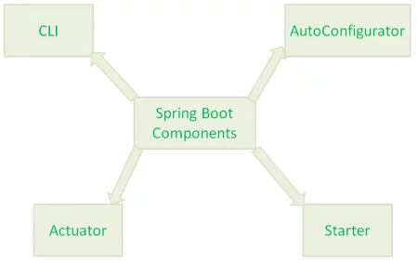

https://www.journaldev.com/7989/key-components-and-internals-of-spring-boot-framework

Spring Boot Actuator:-Spring Boot Actuator provides secured endpoints for monitoring and managing your Spring Boot application. By default, all actuator endpoints are secured. In this chapter, you will learn in detail about how to enable Spring Boot actuator to your application.
https://www.tutorialspoint.com/spring_boot/spring_boot_actuator.htm
Q) what is use of ‘spring.boot.starter’ .
Q) what is use of ‘spring.boot.starter.parent’ :--
The spring-boot-starter-parent dependency is the parent POM providing dependency and plugin management for Spring Boot-based applications. It contains the default versions of Java to use, the default versions of dependencies that Spring Boot uses, and the default configuration of the Maven plugins.
https://howtodoinjava.com/spring-boot2/spring-boot-starter-parent-dependency/

Q) what is the use of @EnableAutoConfiguration : --Enable auto-configuration of the Spring Application Context, attempting to guess and configure beans that you are likely to need. Auto-configuration classes are usually applied based on your classpath and what beans you have defined. For example, if you have tomcat-embedded.jar on your classpath you are likely to want a TomcatServletWebServerFactory (unless you have defined your own ServletWebServerFactory bean).

Use @Profile on a Bean
Profiles are a core feature of the framework — allowing us to map our beans to different profiles — for example, dev, test, and prod.We can then activate different profiles in different environments to bootstrap only the beans we need.
Consider a basic scenario: We have a bean that should only be active during development but not deployed in production.
We annotate that bean with a dev profile, and it will only be present in the container during development. In production, the dev simply won't be active:
@Component
@Profile("dev")
public class DevDatasourceConfig

7. Example: Separate Data Source Configurations Using Profiles
Now that the basics are out of the way, let's take a look at a real example.

Consider a scenario where we have to maintain the data source configuration for both the development and production environments.

Let's create a common interface DatasourceConfig that needs to be implemented by both data source implementations:

public interface DatasourceConfig {
public void setup();
}
Following is the configuration for the development environment:

@Component
@Profile("dev")
public class DevDatasourceConfig implements DatasourceConfig {
@Override
public void setup() {
System.out.println("Setting up datasource for DEV environment. ");
}
}
And configuration for the production environment:

@Component
@Profile("production")
public class ProductionDatasourceConfig implements DatasourceConfig {
@Override
public void setup() {
System.out.println("Setting up datasource for PRODUCTION environment. ");
}
}
Now let's create a test and inject our DatasourceConfig interface; depending on the active profile, Spring will inject DevDatasourceConfig or ProductionDatasourceConfig bean:

public class SpringProfilesWithMavenPropertiesIntegrationTest {
@Autowired
DatasourceConfig datasourceConfig;

public void setupDatasource() {
datasourceConfig.setup();
}
}
When the dev profile is active, Spring injects DevDatasourceConfig object, and when calling then setup() method, the following is the output:

Setting up datasource for DEV environment.
8. Profiles in Spring Boot
Spring Boot supports all the profile configuration outlined so far, with a few additional features.

8.1. Activating or Setting a Profile
The initialization parameter spring.profiles.active, introduced in Section 4, can also be set up as a property in Spring Boot to define currently active profiles. This is a standard property that Spring Boot will pick up automatically:

spring.profiles.active=dev
However, starting Spring Boot 2.4, this property cannot be used in conjunction with spring.config.activate.on-profile, as this could raise a ConfigDataException (i.e. an InvalidConfigDataPropertyException or an InactiveConfigDataAccessException).

To set profiles programmatically, we can also use the SpringApplication class:

freestar
SpringApplication.setAdditionalProfiles("dev");
To set profiles using Maven in Spring Boot, we can specify profile names under spring-boot-maven-plugin in pom.xml:

<plugins>
<plugin>
<groupId>org.springframework.boot</groupId>
<artifactId>spring-boot-maven-plugin</artifactId>
<configuration>
<profiles>
<profile>dev</profile>
</profiles>
</configuration>
</plugin>
...
</plugins>
and execute the Spring Boot-specific Maven goal:

mvn spring-boot:run
8.2. Profile-specific Properties Files
However, the most important profiles-related feature that Spring Boot brings is profile-specific properties files. These have to be named in the format application-{profile}.properties.
Spring Boot will automatically load the properties in an application.properties file for all profiles, and the ones in profile-specific .properties files only for the specified profile.
For example, we can configure different data sources for dev and production profiles by using two files named application-dev.properties and application-production.properties:
In the application-production.properties file, we can set up a MySql data source:
spring.datasource.driver-class-name=com.mysql.cj.jdbc.Driver
spring.datasource.url=jdbc:mysql://localhost:3306/db
spring.datasource.username=root
spring.datasource.password=root
Then we can configure the same properties for the dev profile in the application-dev.properties file, to use an in-memory H2 database:

spring.datasource.driver-class-name=org.h2.Driver
spring.datasource.url=jdbc:h2:mem:db;DB_CLOSE_DELAY=-1
spring.datasource.username=sa
spring.datasource.password=sa
In this way, we can easily provide different configurations for different environments.

As the DB connection is better to be kept in a property file, it remains external to an application and can be changed. We will do so here. But, Spring Boot — by default — provides just one property file ( application.properties). So, how will we segregate the properties based on the environment?
The solution would be to create more property files and add the "profile" name as the suffix and configure Spring Boot to pick the appropriate properties based on the profile.
Then, we need to create three application.properties:
application-dev.properties
application-test.properties
application-prod.properties
Of course, the application.properties will remain as a master properties file, but if we override any key in the profile-specific file, the latter will gain precedence.

We have used the @Profile("Dev") to let the system know that this is the BEAN that should be picked up when we set the application profile to DEV. The other two beans will not be created at all.
One last setting is how to let the system know that this is DEV, TEST, or PROD. But, how do we do this?
We will use the application.properties to use the key below:
spring.profiles.active=dev
1

@Configuration
@PropertySource("classpath:db.properties")
@PropertySource(value = "classpath:root.properties", ignoreResourceNotFound = true)
public class DBConfiguration {

@Value("Default DBConfiguration")
private String defaultName;

@Value("true")
private boolean defaultBoolean;

@Value("10")
private int defaultInt;

@Value("${APP_NAME_NOT_FOUND:Default}")
private String defaultAppName;

// @Value("#{systemProperties['java.home']}")
@Value("${java.home}")
private String javaHome;

@Value("${HOME}")
private String homeDir;

@Bean
public DBConnection getDBConnection() {
DBConnection dbConnection = new DBConnection();
return dbConnection;
}

@Value("Test")
public void printValues(String s, @Value("another variable") String v) {
System.out.println("Input Argument 1 =" + s);
System.out.println("Input Argument 2 =" + v);

System.out.println("Home Directory = " + homeDir);
System.out.println("Default Configuration Name = " + defaultName);
System.out.println("Default App Name = " + defaultAppName);
System.out.println("Java Home = " + javaHome);
System.out.println("Boolean = " + defaultBoolean);
System.out.println("Int = " + defaultInt);

}

}

1 Annotation Basics
  - 1.1 What is The IoC container?
  - 1.2 What is an Application Context in Spring Framework?
  - 1.3 What is Spring Bean or Components?
  - 1.4 What is Component Scanning?
  - 1.5 When to use Component Scanning in a Spring Boot Application?
- 2 Annotations to create a Bean
  - 2.1 @Configuration
  - 2.2 @Bean
  - 2.3 @Component
  - 2.4 @Controller
  - 2.5 @RestController
  - 2.6 @Service
  - 2.7 @Repository
  - 2.8 @Bean vs @Component
3 Configuration Annotations
  - 3.1 @ComponentScan
  - 3.2 @Import
  - 3.3 @PropertySource
  - 3.4 @PropertySources (For Multiple Property Locations)
  - 3.5 @Value
    - 3.5.1 @Value for default Value
    - 3.5.2 @Value for multiple values
- 4 Spring Boot Specific Annotations
  - 4.1 @SpringBootApplication (@Configuration + @ComponentScan + @EnableAutoConfiguration)
  - 4.2 @EnableAutoConfiguration
    - 4.2.1 Use of ‘exclude’ in @EnableAutoConfiguration
    - 4.2.2 Use of ‘excludeName’ in @EnableAutoConfiguration
  - 4.3 @SpringBootConfiguration
  - 4.4 @ConfigurationProperties
  - 4.5 @EnableConfigurationProperties
  - 4.6 @EnableConfigurationPropertiesScan
  - 4.7 @EntityScan and @EnableJpaRepositories
- 5 Links to Other Annotations
0.1 What is Spring Bean or Components?
  - 0.2 What is @Bean in Spring Boot?
- 1 Annotations on Bean Properties
  - 1.1 @Lazy
  - 1.2 @Profile
  - 1.3 @Scope
  - 1.4 @DependsOn
  - 1.5 @Order
  - 1.6 @Primary
  - 1.7 @Conditional
- 2 Annotations on Bean Injection
  - 2.1 @Autowired, @Resource, @Inject
    - 2.1.1 @Autowired
    - 2.1.2 @Autowired Execution Precedence
    - 2.1.3 @Resource Execution Precedence
    - 2.1.4 @Inject Execution Precedence
  - 2.2 @Qualifier
  - 2.3 @Primary vs @Qualifier
- 3 Annotations on Bean State
  - 3.1 @PostConstruct
  - 3.2 @PreDestroy
Table of Contents (Click on links below to navigate) [hide]
- 1 Spring Boot MVC Annotations
  - 1.1 @Controller
  - 1.2 @RequestMapping
  - 1.3 @GetMapping, @PostMapping, @PutMapping, @PatchMapping, @DeleteMapping
    - 1.3.1 @GetMapping vs @RequestMapping
  - 1.4 @ModelAttribute
    - 1.4.1 @ModelAttribute at method argument level
    - 1.4.2 @ModelAttribute at method level
  - 1.5 @CrossOrigin
    - 1.5.1 @CrossOrigin with method (annotated with @RequestMapping)
    - 1.5.2 @CrossOrigin with Controller class
    - 1.5.3 @CrossOrigin with both(Controller class and Handler Method)
- 2 Spring Boot REST Annotations
  - 2.1 @RestController
  - 2.2 @RequestParam
    - 2.2.1 @RequestParam with multiple values of a field
  - 2.3 @PathVariable
  - 2.4 @RequestParam vs @PathVariable
  - 2.5 @ResponseBody
  - 2.6 @RequestBody
  - 2.7 @ResponseBody & @RequestBody for XML format data
Table of Contents (Click on links below to navigate) [hide]
- 1 Spring Security Annotations
  - 1.1 @EnableWebSecurity
  - 1.2 @EnableGlobalMethodSecurity
  - 1.3 @Secured vs @RolesAllowed
  - 1.4 @PreAuthorize and @PostAuthorize
    - 1.4.1 @PreAuthorize
    - 1.4.2 @PostAuthorize
- 2 Spring Scheduling Annotations
  - 2.1 @EnableScheduling
  - 2.2 @Scheduled
    - 2.2.1 @Scheduled with fixedDelay
    - 2.2.2 @Scheduled with fixedDelay & initialDelay
    - 2.2.3 @Scheduled with fixedRate
    - 2.2.4 @Scheduled with cron
  - 2.3 @Schedules
- 3 Transaction Annotations
  - 3.1 @EnableTransactionManagement
  - 3.2 @Transactional
1 Annotations on Spring Errors & Exceptions
  - 1.1 @ResponseStatus
  - 1.2 @ExceptionHandler
  - 1.3 @ContollerAdvice and @RestControllerAdvice
- 2 Spring AOP Annotations
  - 2.1 @EnableAspectJAutoProxy
  - 2.2 @Aspect
  - 2.3 @Pointcut
  - 2.4 @Before
  - 2.5 @After
  - 2.6 @AfterReturning
  - 2.7 @AfterThrowing
  - 2.8 @Around
All Annotations taken from : https://javatechonline.com/spring-boot-annotations-with-examples/#PropertySource

Spring Security Form Login

- Add dependency -
<dependency>
<groupId>org.springframework.boot</groupId>
<artifactId>spring-boot-starter-security</artifactId> <version>2.3.3.RELEASE</version>
</dependency>

- Add spring configuration -
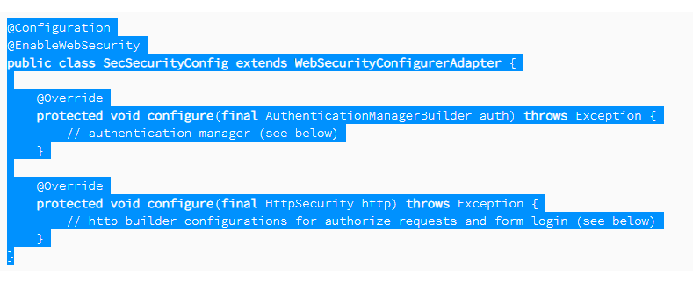

Add Spring Security to the Web Application
To use the above-defined Spring Security configuration, we need to attach it to the web application.
We'll use the WebApplicationInitializer, so we don't need to provide any web.xml:

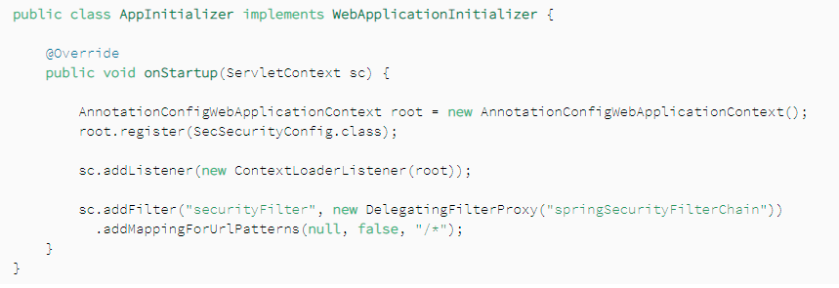
Or below type
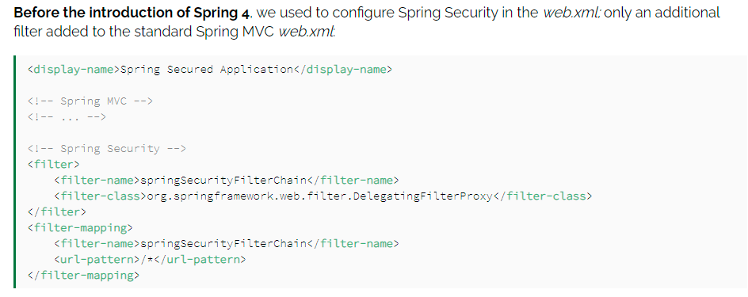
<web-app id = "WebApp_ID" version = "2.4"
xmlns = "http://java.sun.com/xml/ns/j2ee"
xmlns:xsi = "http://www.w3.org/2001/XMLSchema-instance"
xsi:schemaLocation = "http://java.sun.com/xml/ns/j2ee
http://java.sun.com/xml/ns/j2ee/web-app_2_4.xsd">

<display-name>Spring MVC Application</display-name>

<servlet>
<servlet-name>HelloWeb</servlet-name>
<servlet-class>
org.springframework.web.servlet.DispatcherServlet
</servlet-class>
<load-on-startup>1</load-on-startup>
</servlet>

<servlet-mapping>
<servlet-name>HelloWeb</servlet-name>
<url-pattern>*.jsp</url-pattern>
</servlet-mapping>

</web-app>
If you do not want to go with default filename as [servlet-name]-servlet.xml and default location as WebContent/WEB-INF, you can customize this file name and location by adding the servlet listener ContextLoaderListener in your web.xml file as follows −
<web-app...>

<!-------- DispatcherServlet definition goes here----->
....
<context-param>
<param-name>contextConfigLocation</param-name>
<param-value>/WEB-INF/HelloWeb-servlet.xml</param-value>
</context-param>

<listener>
<listener-class>
org.springframework.web.context.ContextLoaderListener
</listener-class>
</listener>

</web-app>

Spring isolation levels type and explain each
In Spring, transaction isolation levels define the degree to which the operations within a transaction are isolated from other concurrent transactions. These isolation levels control how and when the changes made by one transaction are visible to other transactions. Spring's transaction management supports the standard isolation levels defined by the SQL standard.
Spring uses these isolation levels via @Transactional annotation or programmatically using the TransactionTemplate. Each level provides a different degree of isolation, which affects concurrency, performance, and consistency.
Here are the isolation levels supported in Spring:
- 1. ISOLATION_DEFAULT
- Description: This is the default isolation level in Spring, which means it uses the default isolation level of the underlying database. Different databases have different default isolation levels (e.g., READ COMMITTED for most databases).
- Use Case: This is suitable when you want to rely on the database’s configuration and default isolation level.
- Example:
java
Copy code
@Transactional(isolation = Isolation.DEFAULT)
public void someMethod() {
// Transaction code here
}
- 2. ISOLATION_READ_UNCOMMITTED
- Description: This is the lowest isolation level. It allows transactions to read uncommitted changes made by other transactions. This means it can read "dirty" data.
- Issues: Susceptible to dirty reads, non-repeatable reads, and phantom reads.
  - Dirty Reads: Reading data that has been modified by another transaction but not yet committed.
  - Non-repeatable Reads: Data that changes between reads in the same transaction.
  - Phantom Reads: New rows that are added by another transaction can appear between reads in the same transaction.
- Use Case: This isolation level is rarely used, mainly in scenarios where performance is critical, and data consistency is less important (e.g., logging systems).
- Example:
java
Copy code
@Transactional(isolation = Isolation.READ_UNCOMMITTED)
public void someMethod() {
// Transaction code here
}
- 3. ISOLATION_READ_COMMITTED
- Description: This isolation level ensures that a transaction can only read data that has been committed by other transactions. It prevents dirty reads but allows non-repeatable reads and phantom reads.
- Issues: Vulnerable to non-repeatable reads and phantom reads.
- Use Case: The most commonly used isolation level, suitable for many applications. It balances data consistency with performance. Most databases, including PostgreSQL and SQL Server, use READ COMMITTED as the default.
- Example:
java
Copy code
@Transactional(isolation = Isolation.READ_COMMITTED)
public void someMethod() {
// Transaction code here
}
- 4. ISOLATION_REPEATABLE_READ
- Description: This isolation level ensures that if a transaction reads a row, subsequent reads of the same row will return the same data, even if other transactions modify the data and commit. It prevents dirty reads and non-repeatable reads, but it is still susceptible to phantom reads.
- Issues: Vulnerable to phantom reads.
  - Phantom Reads: Occur when a transaction reads a set of rows that match a condition, but another transaction inserts or deletes rows that affect the result set.
- Use Case: Useful when repeatable reads are necessary, such as in financial applications, where the consistency of a record during a transaction is crucial.
- Example:
java
Copy code
@Transactional(isolation = Isolation.REPEATABLE_READ)
public void someMethod() {
// Transaction code here
}
- 5. ISOLATION_SERIALIZABLE
- Description: This is the strictest isolation level. It ensures that transactions are completely isolated from each other, meaning no other transactions can read or write data that a current transaction is working on until it is complete. It prevents dirty reads, non-repeatable reads, and phantom reads by locking entire tables.
- Issues: While this level provides the highest data integrity, it comes at a significant performance cost due to the locking involved. It can lead to a high level of contention and reduced concurrency.
- Use Case: Use SERIALIZABLE only when data integrity is critical and performance impact can be tolerated, such as in systems that deal with sensitive data like banking or inventory systems.
- Example:
java
Copy code
@Transactional(isolation = Isolation.SERIALIZABLE)
public void someMethod() {
// Transaction code here
}
- Table of Isolation Levels and Their Behaviors
Isolation Level | Dirty Read | Non-Repeatable Read | Phantom Read
READ UNCOMMITTED | Yes | Yes | Yes
READ COMMITTED | No | Yes | Yes
REPEATABLE READ | No | No | Yes
SERIALIZABLE | No | No | No
- Summary of When to Use Each Isolation Level
- ISOLATION_READ_UNCOMMITTED: Use when performance is a top priority and data accuracy can be relaxed.
- ISOLATION_READ_COMMITTED: A balanced choice for most applications where dirty reads need to be avoided.
- ISOLATION_REPEATABLE_READ: Use when you want consistent reads during the lifetime of the transaction, but can tolerate phantom reads.
- ISOLATION_SERIALIZABLE: Use when the highest level of data consistency is required, and performance is not the primary concern.

spring propagation levels explain each
In Spring, propagation levels define how the transactions in Spring will interact with each other. When a method annotated with @Transactional is called, Spring needs to determine whether to start a new transaction, use an existing one, or suspend the current transaction. This behavior is controlled by the propagation level in Spring.
Spring provides seven different propagation levels:
- 1. PROPAGATION_REQUIRED
- Description: This is the default propagation level in Spring. It indicates that the method must run within a transaction. If there’s an existing transaction, the method will join that transaction. If no transaction exists, a new one will be started.
- Use Case: This is the most common and default propagation setting, suitable when you want a method to participate in an existing transaction or start a new one if needed.
- Example:
@Transactional(propagation = Propagation.REQUIRED)
public void someMethod() {
// Transactional code
}
- Behavior:
  - If called within an existing transaction, it will run within that transaction.
  - If no transaction exists, it will start a new one.
- 2. PROPAGATION_REQUIRES_NEW
- Description: This propagation level always creates a new transaction. If there’s an existing transaction, it is suspended until the new transaction completes. After the new transaction finishes (commit or rollback), the original transaction resumes.
- Use Case: Use this when you need to run a method in a completely independent transaction from the calling method, e.g., for audit logging or saving important data even if the outer transaction rolls back.
- Example:
@Transactional(propagation = Propagation.REQUIRES_NEW)
public void someMethod() {
// Transactional code
}
- Behavior:
  - Suspends the current transaction (if any) and creates a new one.
  - After the new transaction completes, the suspended transaction resumes.
- 3. PROPAGATION_SUPPORTS
- Description: This level means that the method can run within a transaction if one exists, but it does not require a transaction. If no transaction exists, it will run without one.
- Use Case: Use this when you don’t need a transaction but want to participate in one if it already exists, for example, in read-only operations that don’t always require a transaction.
- Example:
@Transactional(propagation = Propagation.SUPPORTS)
public void someMethod() {
// Transactional code
}
- Behavior:
  - If there is an existing transaction, it participates in it.
  - If there’s no existing transaction, it runs without one.
- 4. PROPAGATION_NOT_SUPPORTED
- Description: This propagation level indicates that the method should never run within a transaction. If an existing transaction is present, it will be suspended, and the method will run without a transaction.
- Use Case: Use this when you explicitly don’t want the method to participate in any transaction, like when performing certain non-transactional operations such as reading from a file.
- Example:
@Transactional(propagation = Propagation.NOT_SUPPORTED)
public void someMethod() {
// Non-transactional code
}
- Behavior:
  - Suspends the current transaction (if any) and runs without a transaction.
- 5. PROPAGATION_MANDATORY
- Description: This level means that the method must be executed within an existing transaction. If no transaction exists, Spring will throw an exception.
- Use Case: Use this when the method must always be executed within the context of an existing transaction, like when ensuring certain methods always participate in a transaction (e.g., for data consistency).
- Example:
java
Copy code
@Transactional(propagation = Propagation.MANDATORY)
public void someMethod() {
// Transactional code
}
- Behavior:
  - If there’s an existing transaction, it participates in it.
  - If no transaction exists, it throws an IllegalTransactionStateException.
- 6. PROPAGATION_NEVER
- Description: This level indicates that the method should never run within a transaction. If a transaction is currently active, Spring will throw an exception.
- Use Case: Use this when you want to ensure that a method never runs within a transaction, like for non-transactional operations that must not participate in any active transaction.
- Example:
@Transactional(propagation = Propagation.NEVER)
public void someMethod() {
// Non-transactional code
}
- Behavior:
  - If there is no active transaction, the method will execute as usual.
  - If a transaction is active, Spring throws an IllegalTransactionStateException.
- 7. PROPAGATION_NESTED
- Description: This propagation level indicates that the method should be executed within a nested transaction if there’s an existing transaction. A nested transaction allows the current transaction to be partially rolled back without affecting the entire transaction. If no transaction exists, it behaves like PROPAGATION_REQUIRED and starts a new transaction.
- Use Case: Use this when you need to execute part of a larger transaction and want the ability to roll back just that part while still committing the rest, such as saving a draft in a content management system.
- Example:
@Transactional(propagation = Propagation.NESTED)
public void someMethod() {
// Transactional code
}
- Behavior:
  - If an existing transaction exists, it creates a nested transaction.
  - If no transaction exists, it creates a new one.
  - A nested transaction can be rolled back independently of the outer transaction.
- Summary of Propagation Levels
Propagation Level | Behavior with Existing Transaction | Behavior without Existing Transaction
REQUIRED | Joins the existing transaction | Starts a new transaction
REQUIRES_NEW | Suspends the existing transaction | Starts a new transaction
SUPPORTS | Joins the existing transaction | Runs without a transaction
NOT_SUPPORTED | Suspends the existing transaction | Runs without a transaction
MANDATORY | Joins the existing transaction | Throws an exception
NEVER | Throws an exception | Runs without a transaction
NESTED | Creates a nested transaction | Starts a new transaction
- Key Use Cases:
- REQUIRED: Default behavior; most commonly used.
- REQUIRES_NEW: Use when you need a separate transaction.
- SUPPORTS: Use for optional transactions (read-only or other non-critical operations).
- NOT_SUPPORTED: Use when you don’t want a transaction.
- MANDATORY: Use when you need to ensure there is always an active transaction.
- NEVER: Use when you want to ensure no transaction is active.
- NESTED: Use for more granular transaction management, where parts of the transaction can be rolled back independently.
By understanding these propagation levels, you can control how transactions should behave within your Spring applications, ensuring correct data integrity and performance in your business logic.

This option is mostly not used in projects.
@Transactional (rollbackFor=Exception.class)
Default is rollbackFor=RunTimeException.class
In Spring, all API classes throw RuntimeException, which means if any method fails, the container will always rollback the ongoing transaction.
The problem is only with checked exceptions. So this option can be used to declaratively rollback a transaction if Checked Exception occurs.
@Transactional (noRollbackFor=IllegalStateException.class)
Indicates that a rollback should not be issued if the target method raises this exception.
Now the last but most important step in transaction management is the placement of @Transactional annotation. Most of the times, there is a confusion where should the annotation be placed: at Service layer or DAO layer?
@Transactional: Service or DAO Layer?
The Service is the best place for putting @Transactional, service layer should hold the detail-level use case behavior for a user interaction that would logically go in a transaction.
HTTP response status codes
Informational responses ( 100 – 199 )
Successful responses ( 200 – 299 )
Redirects ( 300 – 399 )
Client errors ( 400 – 499 )
Server errors ( 500 – 599 )
Information responses

RestTemplate methods : ---
https://springframework.guru/using-resttemplate-in-spring/
Type of http methods in rest :- https://restfulapi.net/http-methods/

Global Transaction Management (GTA/XA)
How to manage transactions with two databases in spring boot
Managing transactions across two or more databases in a Spring Boot application can be challenging, but it can be achieved by using Spring's support for distributed transactions. Here’s how you can manage transactions with two databases in a Spring Boot application:
- Steps to Manage Transactions Across Two Databases
- Configure Multiple Data Sources: You need to configure multiple DataSource beans in your Spring Boot application, one for each database.
- Configure ChainedTransactionManager or Use JTA/XA Transactions: To manage transactions across multiple databases, you can either use:
  - ChainedTransactionManager (provided by Spring)
  - JTA/XA Transactions (for global/distributed transactions)
JTA/XA Transactions are more robust and the standard way to manage distributed transactions, while ChainedTransactionManager is a simpler approach but has some limitations (e.g., doesn't support rollbacks well across multiple databases).
- Declare Transactional Boundaries: Use the @Transactional annotation to manage the transactional boundaries.
- Approach 1: Using ChainedTransactionManager
- 1.1. Configure Two Data Sources
You need to define two DataSource beans and corresponding EntityManagerFactory and TransactionManager for each.
@Configuration
public class DataSourceConfig {

@Bean
@Primary
@ConfigurationProperties(prefix = "spring.datasource.db1")
public DataSource dataSource1() {
return DataSourceBuilder.create().build();
}

@Bean
@ConfigurationProperties(prefix = "spring.datasource.db2")
public DataSource dataSource2() {
return DataSourceBuilder.create().build();
}

// EntityManagerFactory and TransactionManager for DB1
@Bean(name = "entityManagerFactory1")
public LocalContainerEntityManagerFactoryBean entityManagerFactory1(
EntityManagerFactoryBuilder builder, @Qualifier("dataSource1") DataSource dataSource) {
return builder
.dataSource(dataSource)
.packages("com.example.entity.db1") // Specify the entity packages for DB1
.build();
}

@Bean(name = "transactionManager1")
public PlatformTransactionManager transactionManager1(
@Qualifier("entityManagerFactory1") EntityManagerFactory entityManagerFactory) {
return new JpaTransactionManager(entityManagerFactory);
}

// EntityManagerFactory and TransactionManager for DB2
@Bean(name = "entityManagerFactory2")
public LocalContainerEntityManagerFactoryBean entityManagerFactory2(
EntityManagerFactoryBuilder builder, @Qualifier("dataSource2") DataSource dataSource) {
return builder
.dataSource(dataSource)
.packages("com.example.entity.db2") // Specify the entity packages for DB2
.build();
}

@Bean(name = "transactionManager2")
public PlatformTransactionManager transactionManager2(
@Qualifier("entityManagerFactory2") EntityManagerFactory entityManagerFactory) {
return new JpaTransactionManager(entityManagerFactory);
}

// ChainedTransactionManager combining the two transaction managers
@Bean
public PlatformTransactionManager chainedTransactionManager(
@Qualifier("transactionManager1") PlatformTransactionManager transactionManager1,
@Qualifier("transactionManager2") PlatformTransactionManager transactionManager2) {
return new ChainedTransactionManager(transactionManager1, transactionManager2);
}
}
- 1.2. Use @Transactional for Distributed Transactions
With the ChainedTransactionManager configured, you can now use @Transactional annotation to manage transactions across both databases.
java
Copy code
@Service
public class MyService {

@Autowired
private Repository1 repository1; // DB1 repository
@Autowired
private Repository2 repository2; // DB2 repository

@Transactional("chainedTransactionManager")
public void saveDataInBothDatabases(Entity1 entity1, Entity2 entity2) {
repository1.save(entity1); // Save entity to DB1
repository2.save(entity2); // Save entity to DB2
}
}
- Approach 2: Using JTA/XA Transactions
JTA (Java Transaction API) enables distributed (global) transactions across multiple resources. XA transactions are the standard protocol for distributed transactions.
<dependency>
<groupId>com.atomikos</groupId>
<artifactId>transactions-jta</artifactId>
<version>5.0.8</version>
</dependency>
<dependency>
<groupId>com.atomikos</groupId>
<artifactId>transactions-essentials</artifactId>
<version>5.0.8</version>
</dependency>

- 2.1. Configure Two Data Sources with XA Support
You need to configure two XA-compatible DataSource beans. Most commonly used databases have XA-compliant drivers.
@Configuration
public class XADataSourceConfig {
@Bean
@Primary
@ConfigurationProperties(prefix = "spring.datasource.db1")
public DataSource xaDataSource1() {
return new AtomikosDataSourceBean(); // Or any other XA datasource implementation
/**
OracleXADataSource xaDataSource = new OracleXADataSource(); //Oracle XA DataSource
PGXADataSource pgXADataSource = new PGXADataSource(); //PostgreSQL XA DataSource

HikariDataSource hikariDataSource = new HikariDataSource(); // HikariCP with JTA
DB2XADataSource xaDataSource = new DB2XADataSource(); // IBM WebSphere Transaction Manager (UTX/XA)
OracleXADataSource xaDataSource = new OracleXADataSource(); // WebLogic JTA/XA Transaction Manager
PoolingDataSource ds = new PoolingDataSource(); // Bitronix Transaction Manager (BTM)
*/

}

@Bean
@ConfigurationProperties(prefix = "spring.datasource.db2")
public DataSource xaDataSource2() {
return new AtomikosDataSourceBean();
}

@Bean(name = "transactionManager")
public JtaTransactionManager transactionManager(UserTransaction userTransaction, TransactionManager transactionManager) {
return new JtaTransactionManager(userTransaction, transactionManager);
}
}
- 2.2. Configure XA EntityManagerFactory
You need to create separate EntityManagerFactory for each XA DataSource.
java
Copy code
@Bean(name = "entityManagerFactory1")
public LocalContainerEntityManagerFactoryBean entityManagerFactory1(
EntityManagerFactoryBuilder builder, @Qualifier("xaDataSource1") DataSource dataSource) {
return builder
.dataSource(dataSource)
.packages("com.example.entity.db1")
.build();
}

@Bean(name = "entityManagerFactory2")
public LocalContainerEntityManagerFactoryBean entityManagerFactory2(
EntityManagerFactoryBuilder builder, @Qualifier("xaDataSource2") DataSource dataSource) {
return builder
.dataSource(dataSource)
.packages("com.example.entity.db2")
.build();
}
- 2.3. Use @Transactional for Global Transactions
You can now use the @Transactional annotation, and the JTA transaction manager will manage the distributed transaction across both databases.
@Service
public class MyService {

@Autowired
private Repository1 repository1; // DB1 repository
@Autowired
private Repository2 repository2; // DB2 repository

@Transactional
public void saveDataInBothDatabases(Entity1 entity1, Entity2 entity2) {
repository1.save(entity1); // Save entity to DB1
repository2.save(entity2); // Save entity to DB2
}
}
- Pros and Cons of Each Approach
Approach | Pros | Cons
ChainedTransactionManager | Simple to implement. No need for an external transaction manager. | Limited rollback across multiple databases.
JTA/XA Transactions | Robust support for distributed transactions. Consistent rollback. | Requires XA-compatible data sources and external management overhead.
- Conclusion
- For simpler cases where rollback across databases isn’t a strict requirement, you can use ChainedTransactionManager.
- For more robust, production-grade distributed transactions, especially in microservices or complex systems, JTA/XA transactions are a better choice.

Spring

What is Spring Framework?
- Spring is a powerful open source, loosely coupled, light weight, java based application framework meant for reducing the complexity of developing enterprise level applications. This framework is also called as the "framework of frameworks" as spring provides support to various other important frameworks like JSF, Hibernate, Structs, EJB etc.
- There are around 20 modules which are generalized into the following types:
  - Core Container
  - Data Access/Integration
  - Web
  - AOP (Aspect Oriented Programming)
  - Instrumentation
  - Messaging
  - Test
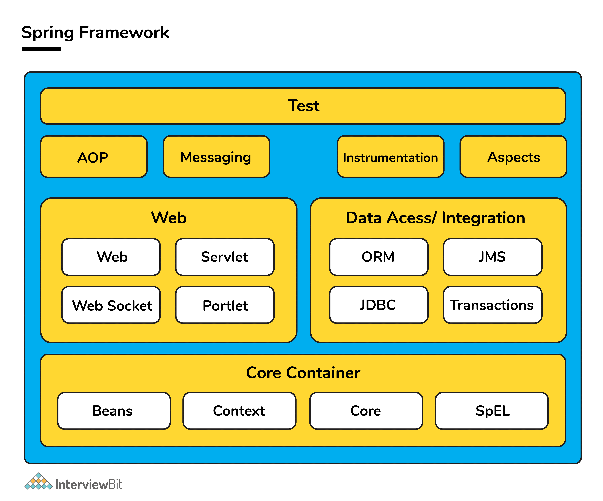

Spring handles all the infrastructure related aspects which lets the programmer to focus mostly on application development.

What are the features of Spring Framework?
- Spring framework follows layered architecture pattern that helps in the necessary components selection along with providing a robust and cohesive framework for J2EE applications development.
- The AOP (Aspect Oriented Programming) part of Spring supports unified development by ensuring separation of application's business logic from other system services.
- Spring provides highly configurable MVC web application framework which has the ability to switch to other frameworks easily.
- Provides provision of creation and management of the configurations and defining the lifecycle of application objects.
- Spring has a special design principle which is known as IoC (Inversion of Control) that supports objects to give their dependencies rather than looking for creating dependent objects.
- Spring is a lightweight, java based, loosely coupled framework.
- Spring provides generic abstraction layer for transaction management that is also very useful for container-less environments.
- Spring provides a convenient API to translate technology-specific exceptions (thrown by JDBC, Hibernate or other frameworks) into consistent, unchecked exceptions. This introduces abstraction and greatly simplifies exception handling.

Spring, Spring Core, Spring IoC Interview Questions

1. What is a Spring configuration file?
Spring configuration file is basically a XML file which mainly contains the classes information and describes how those classes are configured and linked to each other. The XML configuration files are verbose and more clean.

2. What do you mean by IoC (Inversion of Control) Container?
Spring container forms the core of the Spring Framework. The Spring container uses Dependency Injection (DI) for managing the application components by creating objects, wiring them together along with configuring and managing their overall life cycles. The instructions for the spring container to do the tasks can be provided either by XML configuration, Java annotations or Java code.
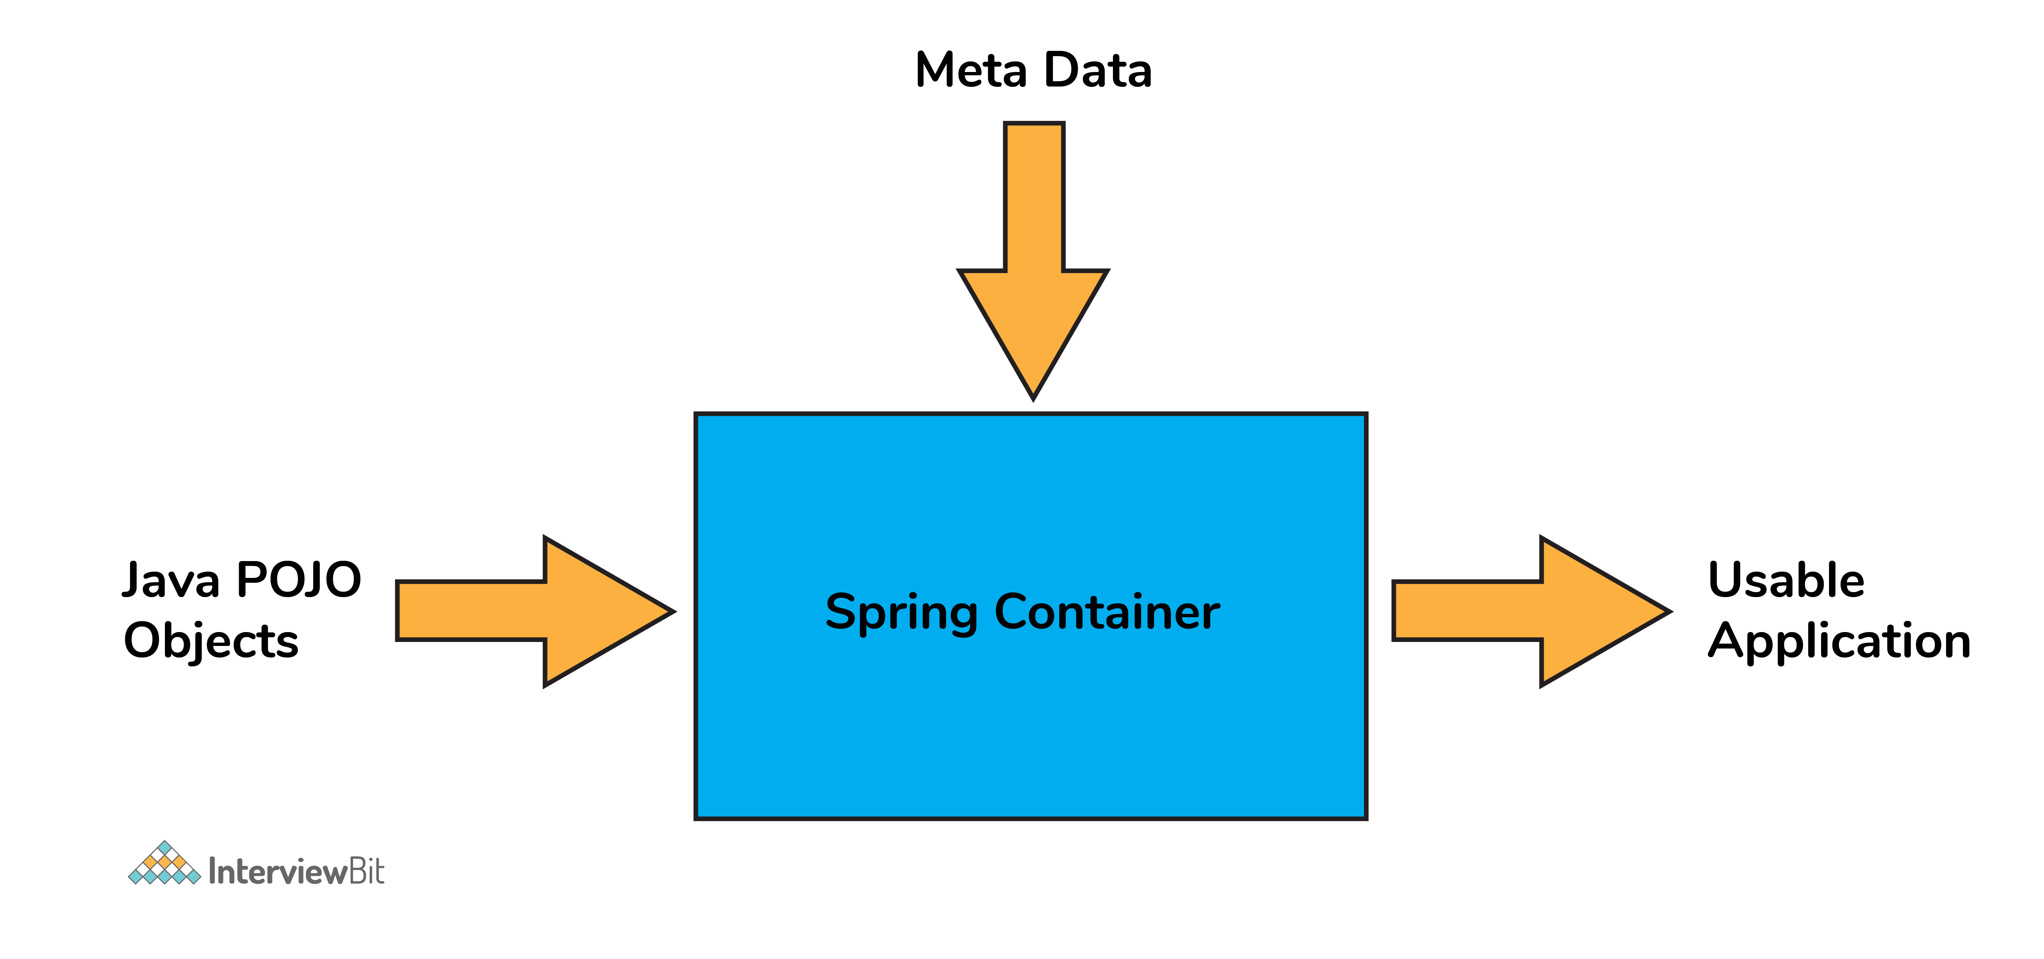

3. What do you understand by Dependency Injection?
The main idea in Dependency Injection is that you don't have to create your objects but you just have to describe how they should be created.
- The components and services need not be connected by us in the code directly. We have to describe which services are needed by which components in the configuration file. The IoC container present in Spring will wire them up together.
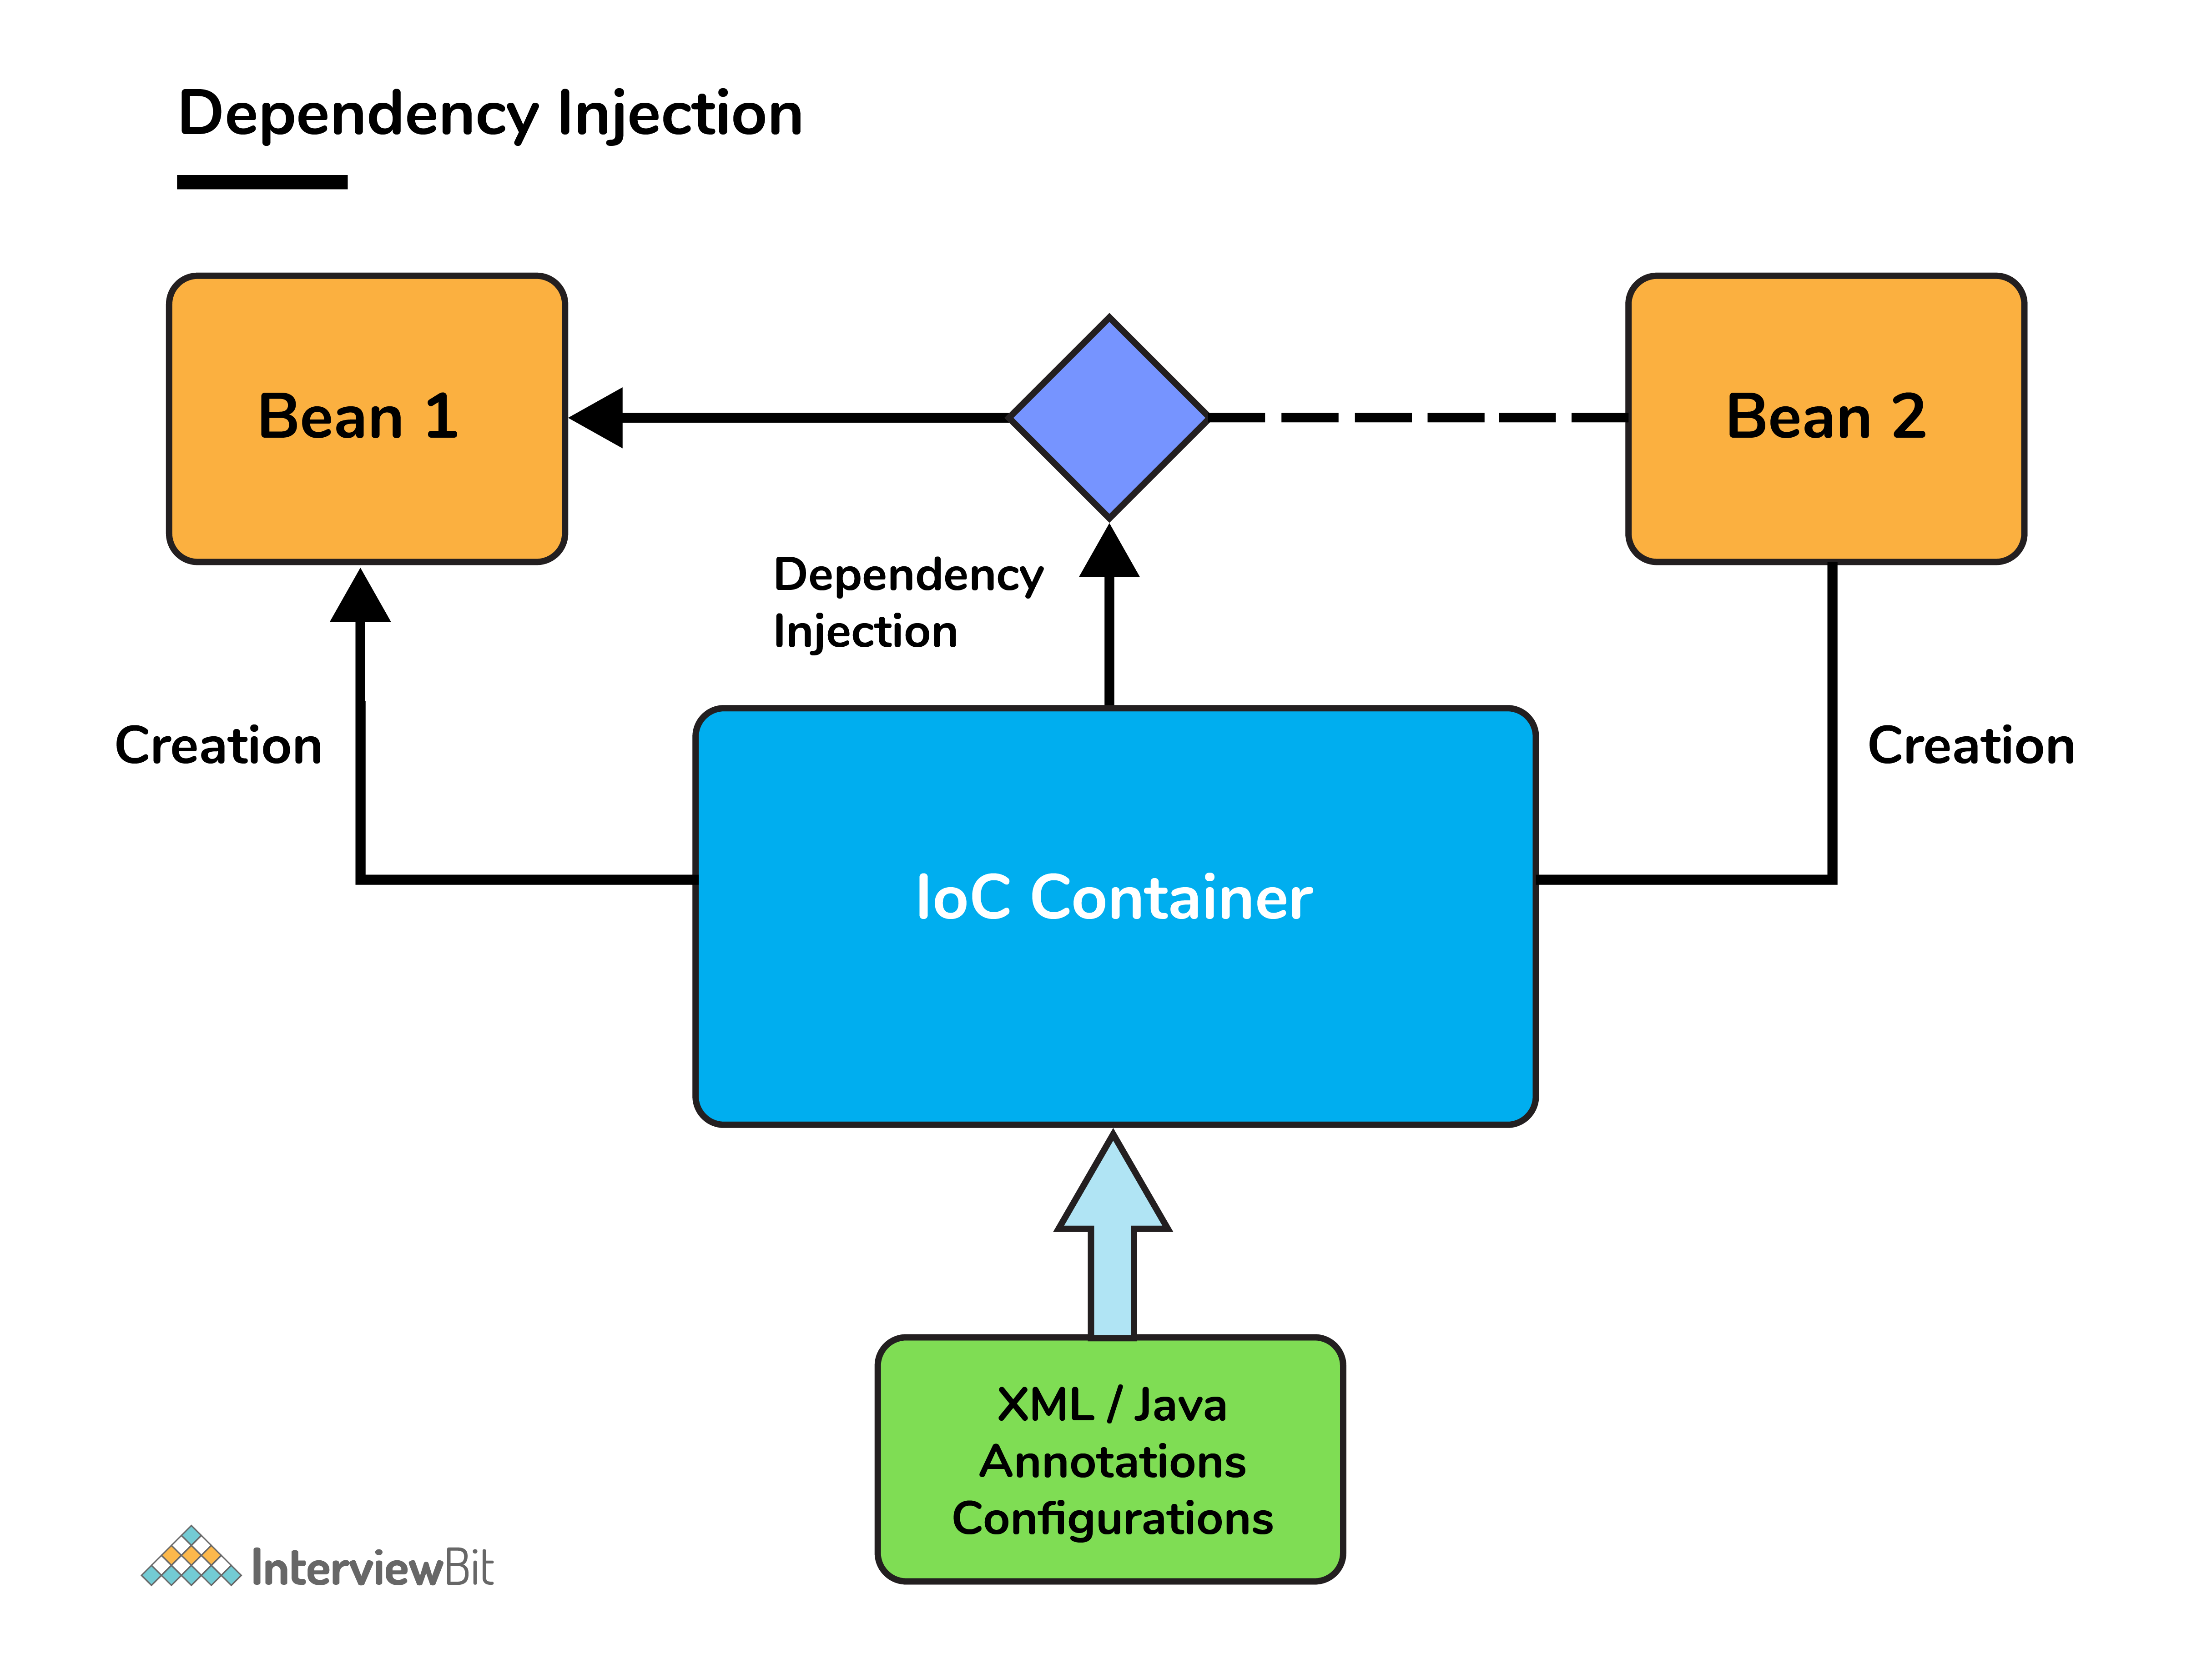
- In Java, the 2 major ways of achieving dependency injection are:
  - Constructor injection: Here, IoC container invokes the class constructor with a number of arguments where each argument represents a dependency on the other class.
  - Setter injection: Here, the spring container calls the setter methods on the beans after invoking a no-argument static factory method or default constructor to instantiate the bean.

4. Explain the difference between constructor and setter injection?
- In constructor injection, partial injection is not allowed whereas it is allowed in setter injection.
- The constructor injection doesn’t override the setter property whereas the same is not true for setter injection.
- Constructor injection creates a new instance if any modification is done. Creation of new instance is not possible in setter injection.
- In case the bean has many properties, then constructor injection is preferred. If it has few properties, then setter injection is preferred.

6. How is the configuration meta data provided to the spring container?
- There are 3 ways of providing the configuration meta data. They are as follows:
  - XML-Based configuration: The bean configurations and its dependencies are specified in XML configuration files. This starts with a bean tag as shown below:
  - <bean id="interviewBitBean" class="org.intervuewBit.firstSpring.InterviewBitBean">
  - <property name="name" value="InterviewBit"></property>
  - </bean>
  - Annotation-Based configuration: Instead of XML approach, the beans can be configured into the component class itself by using annotations on the relevant class, method, or field declaration.
    - Annotation wiring is not active in the Spring container by default. This has to be enabled in the Spring XML configuration file as shown below
    - <beans>
    - <context:annotation-config/>
    - <!-- bean definitions go here -->
    - </beans>
  - Java-based configuration: Spring Framework introduced key features as part of new Java-configuration support. This makes use of the @Configuration annotated classes and @Bean annotated methods. Note that:
    - @Bean annotation has the same role of the <bean/> element.
    - Classes annotated with @Configuration allows to define inter-bean dependencies by simply calling other @Bean methods in the same class.

7. What are the bean scopes available in Spring?
The Spring Framework has five scope supports. They are:
- Singleton: The scope of bean definition while using this would be single instance per IoC container.
- Prototype: Here, the scope for a single bean definition can be any number of object instances.
- Request: The scope of bean definition is an HTTP-request.
- Session: Here, the scope of bean definition is HTTP-session.
- Global-session: The scope of bean definition here is an Global HTTP-session.
Note: The last three scopes are available only if the users use web-aware ApplicationContext containers.

8. Explain Bean life cycle in Spring Bean Factory Container.

Bean life cycle is as follows:
The Spring Bean lifecycle defines the series of events that occur during the creation, initialization, usage, and destruction of a Spring bean. Understanding this lifecycle is crucial for developers to properly manage resources, initialization logic, or cleanup tasks associated with beans.
Here’s an overview of the Spring Bean lifecycle and the key methods involved in each stage.
- Spring Bean Lifecycle Phases
- Instantiation (Bean Creation)
- Property Setting (Dependency Injection)
- Initialization
- Post-Initialization
- Bean Usage
- Destruction
- Lifecycle Methods Involved
- 1. Instantiation (Bean Creation)
- The Spring container creates a new instance of the bean using a constructor or factory method.
- Method: The object is simply instantiated, but at this point, no properties are set yet.
- 2. Property Setting (Dependency Injection)
- Spring performs dependency injection by setting the properties of the bean, such as injecting other beans or values.
- Method: Spring sets the properties based on configurations like XML, annotations (@Autowired, @Value), or Java-based configuration.
- 3. BeanNameAware Interface
- If the bean implements the BeanNameAware interface, Spring calls the setBeanName() method to pass the bean’s name (as defined in the Spring configuration) to the bean.
- Method: setBeanName(String name)
  - Purpose: To give the bean access to its ID/name in the Spring context.
- 4. BeanFactoryAware Interface
- If the bean implements BeanFactoryAware, Spring will invoke the setBeanFactory() method, passing the BeanFactory instance to the bean.
- Method: setBeanFactory(BeanFactory beanFactory)
  - Purpose: To give the bean access to the BeanFactory it was created in, allowing for access to other beans if needed.
- 5. ApplicationContextAware Interface
- If the bean implements ApplicationContextAware, Spring will invoke the setApplicationContext() method, passing the ApplicationContext instance to the bean.
- Method: setApplicationContext(ApplicationContext context)
  - Purpose: To give the bean access to the application context, which provides additional capabilities compared to BeanFactory, such as event propagation and bean lifecycle control.
- 6. PostConstruct Method
- If the bean contains a method annotated with @PostConstruct, this method is called after the properties are set but before any other initialization logic.
- Method: @PostConstruct (Optional)
  - Purpose: To run any custom initialization code.
- 7. Custom Initialization with InitializingBean or init-method
- If the bean implements the InitializingBean interface, Spring will call its afterPropertiesSet() method after the bean properties are set.
- Alternatively, you can define an initialization method via XML (init-method) or using the @Bean(initMethod="init") attribute in Java configuration.
- Method: afterPropertiesSet() or Custom init-method
  - Purpose: To execute any custom initialization logic (e.g., resource allocation, validation, etc.).
- 8. BeanPostProcessor (Post-Initialization)
- Spring will apply any BeanPostProcessor beans that have been registered in the context. This step involves two methods:
  - postProcessBeforeInitialization(): Executed before the initialization methods are called.
  - postProcessAfterInitialization(): Executed after the initialization methods.
- Method: postProcessBeforeInitialization() and postProcessAfterInitialization()
  - Purpose: To allow for additional customization of the bean, such as wrapping, modifying, or enhancing its behavior.
- 9. Bean Usage
- The bean is fully initialized and ready for use by the Spring container. At this point, the bean can be injected into other beans or used to fulfill requests.
- Method: No specific method, just the bean usage in the application.
- 10. PreDestroy Method
- If the bean contains a method annotated with @PreDestroy, this method is called just before the bean is destroyed and removed from the Spring container.
- Method: @PreDestroy (Optional)
  - Purpose: To handle cleanup activities before the bean is destroyed (e.g., closing resources, file streams, database connections).
- 11. Custom Destruction with DisposableBean or destroy-method
- If the bean implements the DisposableBean interface, Spring will call the destroy() method when the container is shutting down or when the bean is being removed.
- Alternatively, you can define a custom destroy method using the destroy-method attribute in XML or Java configuration (@Bean(destroyMethod="destroy")).
- Method: destroy() or Custom destroy-method
  - Purpose: To handle resource deallocation and cleanup.
- Diagram: Spring Bean Lifecycle with Key Methods
sql
Copy code
+---------------------------+
| Instantiation | --> Bean object is created
+---------------------------+
|
+---------------------------+
| Property Injection | --> Spring injects dependencies
+---------------------------+
|
+---------------------------+
| setBeanName() | --> BeanNameAware (optional)
+---------------------------+
|
+---------------------------+
| setBeanFactory() | --> BeanFactoryAware (optional)
+---------------------------+
|
+---------------------------+
| setApplicationContext() | --> ApplicationContextAware (optional)
+---------------------------+
|
+---------------------------+
| @PostConstruct Method | --> Optional custom initialization
+---------------------------+
|
+---------------------------+
| afterPropertiesSet() | --> InitializingBean or init-method
+---------------------------+
|
+---------------------------+
| BeanPostProcessor | --> postProcessBeforeInitialization()
+---------------------------+
|
+---------------------------+
| BeanPostProcessor | --> postProcessAfterInitialization()
+---------------------------+
|
+---------------------------+
| Bean Usage | --> Bean is fully initialized and used
+---------------------------+
|
+---------------------------+
| @PreDestroy | --> Optional pre-destroy method
+---------------------------+
|
+---------------------------+
| destroy() | --> DisposableBean or destroy-method
+---------------------------+
- Example
Here's an example to demonstrate the Spring Bean lifecycle using annotations and a configuration class:
java
Copy code
import javax.annotation.PostConstruct;
import javax.annotation.PreDestroy;
import org.springframework.beans.factory.BeanNameAware;
import org.springframework.context.annotation.Bean;
import org.springframework.context.annotation.Configuration;
import org.springframework.context.annotation.Scope;
import org.springframework.stereotype.Component;

@Component
public class MyBean implements BeanNameAware {

private String beanName;

@Override
public void setBeanName(String name) {
this.beanName = name;
System.out.println("BeanNameAware: Bean name is set to " + name);
}

@PostConstruct
public void init() {
System.out.println("PostConstruct: Bean is initialized");
}

@PreDestroy
public void cleanup() {
System.out.println("PreDestroy: Bean is being destroyed");
}
}

@Configuration
class AppConfig {

@Bean(initMethod = "customInit", destroyMethod = "customDestroy")
@Scope("singleton")
public MyBean myBean() {
return new MyBean();
}
}
- Key Takeaways:
- Initialization occurs through @PostConstruct, InitializingBean, or custom init-method.
- Post-Initialization customization can be handled using BeanPostProcessor.
- Destruction logic can be managed with @PreDestroy, DisposableBean, or custom destroy-

- The IoC container instantiates the bean from the bean’s definition in the XML file.
- Spring then populates all of the properties using the dependency injection as specified in the bean definition.
- The bean factory container calls setBeanName() which takes the bean ID and the corresponding bean has to implement BeanNameAware interface.
- The factory then calls setBeanFactory() by passing an instance of itself (if BeanFactoryAware interface is implemented in the bean).
- If BeanPostProcessors is associated with a bean, then the preProcessBeforeInitialization() methods are invoked.
- If an init-method is specified, then it will be called.
- Lastly, postProcessAfterInitialization() methods will be called if there are any BeanPostProcessors associated with the bean needs to be run post the creation.

10. What is auto wiring and name the different modes of it?
The IoC container autowires relationships between the application beans. Spring lets collaborators to resolve which bean has to be wired automatically by inspecting the contents of the BeanFactory. Different modes of this process are:
- no: This means no autowiring and is the default setting. Explicit bean reference should be used for wiring.
- byName: The bean dependency is injected according to name of the bean. This matches and wires its properties with the beans defined by the same names as per the configuration.
- byType: This injects the bean dependency based on type.
- constructor: Here, it injects the bean dependency by calling the constructor of the class. It has a large number of parameters.
- autodetect: First the container tries to wire using autowire by constructor, if it isnt possible then it tries to autowire by byType.

11. What are the limitations of auto wiring?
- Overriding possibility: Dependencies are specified using <constructor-arg> and <property> settings which overrides autowiring.
- Data types restriction: Primitive data types, Strings and Classes can’t be autowired.

Spring Boot

1. What do you understand by the term 'Spring Boot'?
- Spring Boot is a open source, java based framework which provides support for Rapid Application Development and gives a platform for developing stand-alone and production ready spring applications with needs for very few configurations.

2. Explain the advantages of using Spring Boot for application development.
- Spring Boot helps to create stand-alone applications which can be started using java.jar (Doesn't require to configure WAR files).
- Spring Boot also offers pinpointed 'started' POMs to Maven configuration.
- Has provision to embed Undertow, Tomcat, Jetty or other web servers directly.
- Auto-Configuration: Provides a way to automatically configure an application based on the dependencies present on the classpath.
- Spring Boot was developed with the intention of lessening the lines of code.
- It offers production ready support like monitoring and apps developed using spring boot is easier to launch.

3. Differentiate between Spring and Spring Boot.
- The Spring Framework provides multiple features like dependency injection, data binding, aspect-oriented programming (AOP), data access, and many more that helps easier development of web applications whereas Spring Boot helps in easier usage of the Spring Framework by simplifying or managing various loosely coupled blocks of Spring which are tedious and have a potential of becoming messy.
- Spring boot simplifies commonly used spring dependencies and runs applications straight from a command line. It also doesn’t require an application container and it helps in monitoring several components and configures them externally.

4. What are the features of Spring Boot?
- Spring Boot CLI – This allows you to Groovy / Maven for writing Spring boot application and avoids boilerplate code.
- Starter Dependency – With the help of this feature, Spring Boot aggregates common dependencies together and eventually improves productivity and reduces the burden on
- Spring Initializer – This is a web application that helps a developer in creating an internal project structure. The developer does not have to manually set up the structure of the project while making use of this feature.
- Auto-Configuration – This helps in loading the default configurations according to the project you are working on. In this way, unnecessary WAR files can be avoided.
- Spring Actuator – Spring boot uses actuator to provide "Management EndPoints" which helps the developer in going through the Application Internals, Metrics etc.
- Logging and Security – This ensures that all the applications made using Spring Boot are properly secured without any hassle.

5. What does @SpringBootApplication annotation do internally?
- As per the Spring Boot documentation, the @SpringBootApplication annotation is one point replacement for using @Configuration, @EnableAutoConfiguration and @ComponentScan annotations alongside their default attributes.
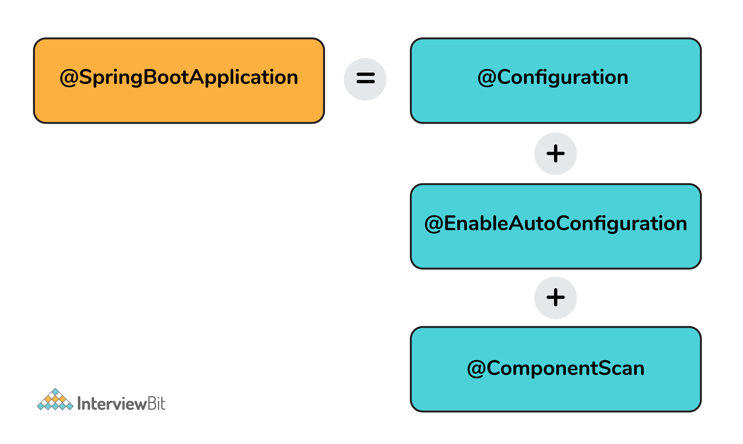
- This enables the developer to use a single annotation instead of using multiple annotations thus lessening the lines of code. However, Spring provides loosely coupled features which is why we can use these annotations as per our project needs.

6. What are the effects of running Spring Boot Application as "Java Application"?
- The application automatically launches the tomcat server as soon as it sees that we are running a web application.

7. What is Spring Boot dependency management system?
- It is basically used to manage dependencies and configuration automatically without the need of specifying the version for any of that dependencies.

8. What are the possible sources of external configuration?
- Spring Boot allows the developers to run the same application in different environments by making use of its feature of external configuration. This uses environment variables, properties files, command-line arguments, YAML files, and system properties to mention the required configuration properties for its corresponding environments. Following are the sources of external configuration:
  - Command-line properties – Spring Boot provides support for command-line arguments and converts these arguments to properties and then adds them to the set of environment properties.
  - Application Properties – By default, Spring Boot searches for the application properties file or its YAML file in the current directory of the application, classpath root or config directory to load the properties.
  - Profile-specific properties – Properties are loaded from the application-{profile}.properties file or its YAML file. This file resides in the same location as that of the non-specific property files and the {profile} placeholder refers to an active profile or an environment.

9. Can we change the default port of the embedded Tomcat server in Spring boot?
- Yes, we can change it by using the application properties file by adding a property of server.port and assigning it to any port you wish to.
- For example, if you want the port to be 8081, then you have to mention server.port=8081. Once the port number is mentioned, the application properties file will be automatically loaded by Spring Boot and the specified configurations will be applied on to the application.

10. Can you tell how to exclude any package without using the basePackages filter?
- We can use the exclude attribute while using the annotation @SpringBootApplication as follows
- @SpringBootApplication(exclude= {Student.class})
- public class InterviewBitAppConfiguration {}

11. How to disable specific auto-configuration class?
- You can use the exclude attribute of @EnableAutoConfiguration for this purpose as shown below:
- @EnableAutoConfiguration(exclude = {InterviewBitAutoConfiguration.class})
If the class is not specified on the classpath, we can specify the fully qualified name as value for the excludeName.
//By using "excludeName"
@EnableAutoConfiguration(excludeName={Foo.class})
- You can add into the application.properties and multiple classes can be added by keeping it comma separated.

12. Can the default web server in the Spring Boot application be disabled?
Yes! application.properties is used to configure the web application type, by mentioning spring.main.web-application-type=none.

13. What are the uses of @RequestMapping and @RestController annotations in Spring Boot?
- @RequestMapping:
  - This provides the routing information and informs Spring that any HTTP request matching the URL must be mapped to the respective method.
  - org.springframework.web.bind.annotation.RequestMapping has to be imported to use this annotation.
- @RestController:
  - This is applied to a class to mark it as a request handler thereby creating RESTful web services using Spring MVC. This annotation adds the @ResponseBody and @Controller annotation to the class.
  - org.springframework.web.bind.annotation.RestController has to be imported to use this annotation.

Spring MVC

1. What is the Spring MVC framework?
- Spring MVC is request driven framework and one of the core components of the Spring framework.
- It comes with ready to use loosely coupled components and elements that greatly aids developers in building flexible and robust web applications.
- The MVC (Model - View - Controller) architecture separates and provides loose coupling between the different aspects of the application – input logic (Model), business logic (Controller), and UI logic (View).

2. What are the benefits of Spring MVC framework over other MVC frameworks?
- Clear separation of roles – There is a specialised dedicated object for every role.
- Reusable business code logic – With Spring MVC, there is no need for duplicating the code. Existing objects can be used as commands instead of replicating them in order to extend a particular framework base class.
- Spring MVC framework provides customizable binding and validation.
- Also provides customizable locale and theme resolution.
- Spring MVC supports customizable handler mapping and view resolution too.

3. What is DispatcherServlet in Spring MVC?
- Spring MVC framework is built around a central servlet called DispatcherServlet that handles all the HTTP requests and responses. The DispatcherServlet does a lot more than that:
  - It seamlessly integrates with the IoC container and allows you to use each feature of Spring in a easier manner.
  - The DispatcherServlet contacts HandlerMapping to call the appropriate Controller for processing the request on receiving it. Then, the controller calls appropriate service methods to set or process the Model data. The service processes the data and returns the view name to DispatcherServlet. DispatcherServlet then takes help of ViewResolver and picks up the defined view for the request. Once the view is decided, the DispatcherServlet passes the Model data to View where it is finally rendered on the browser.
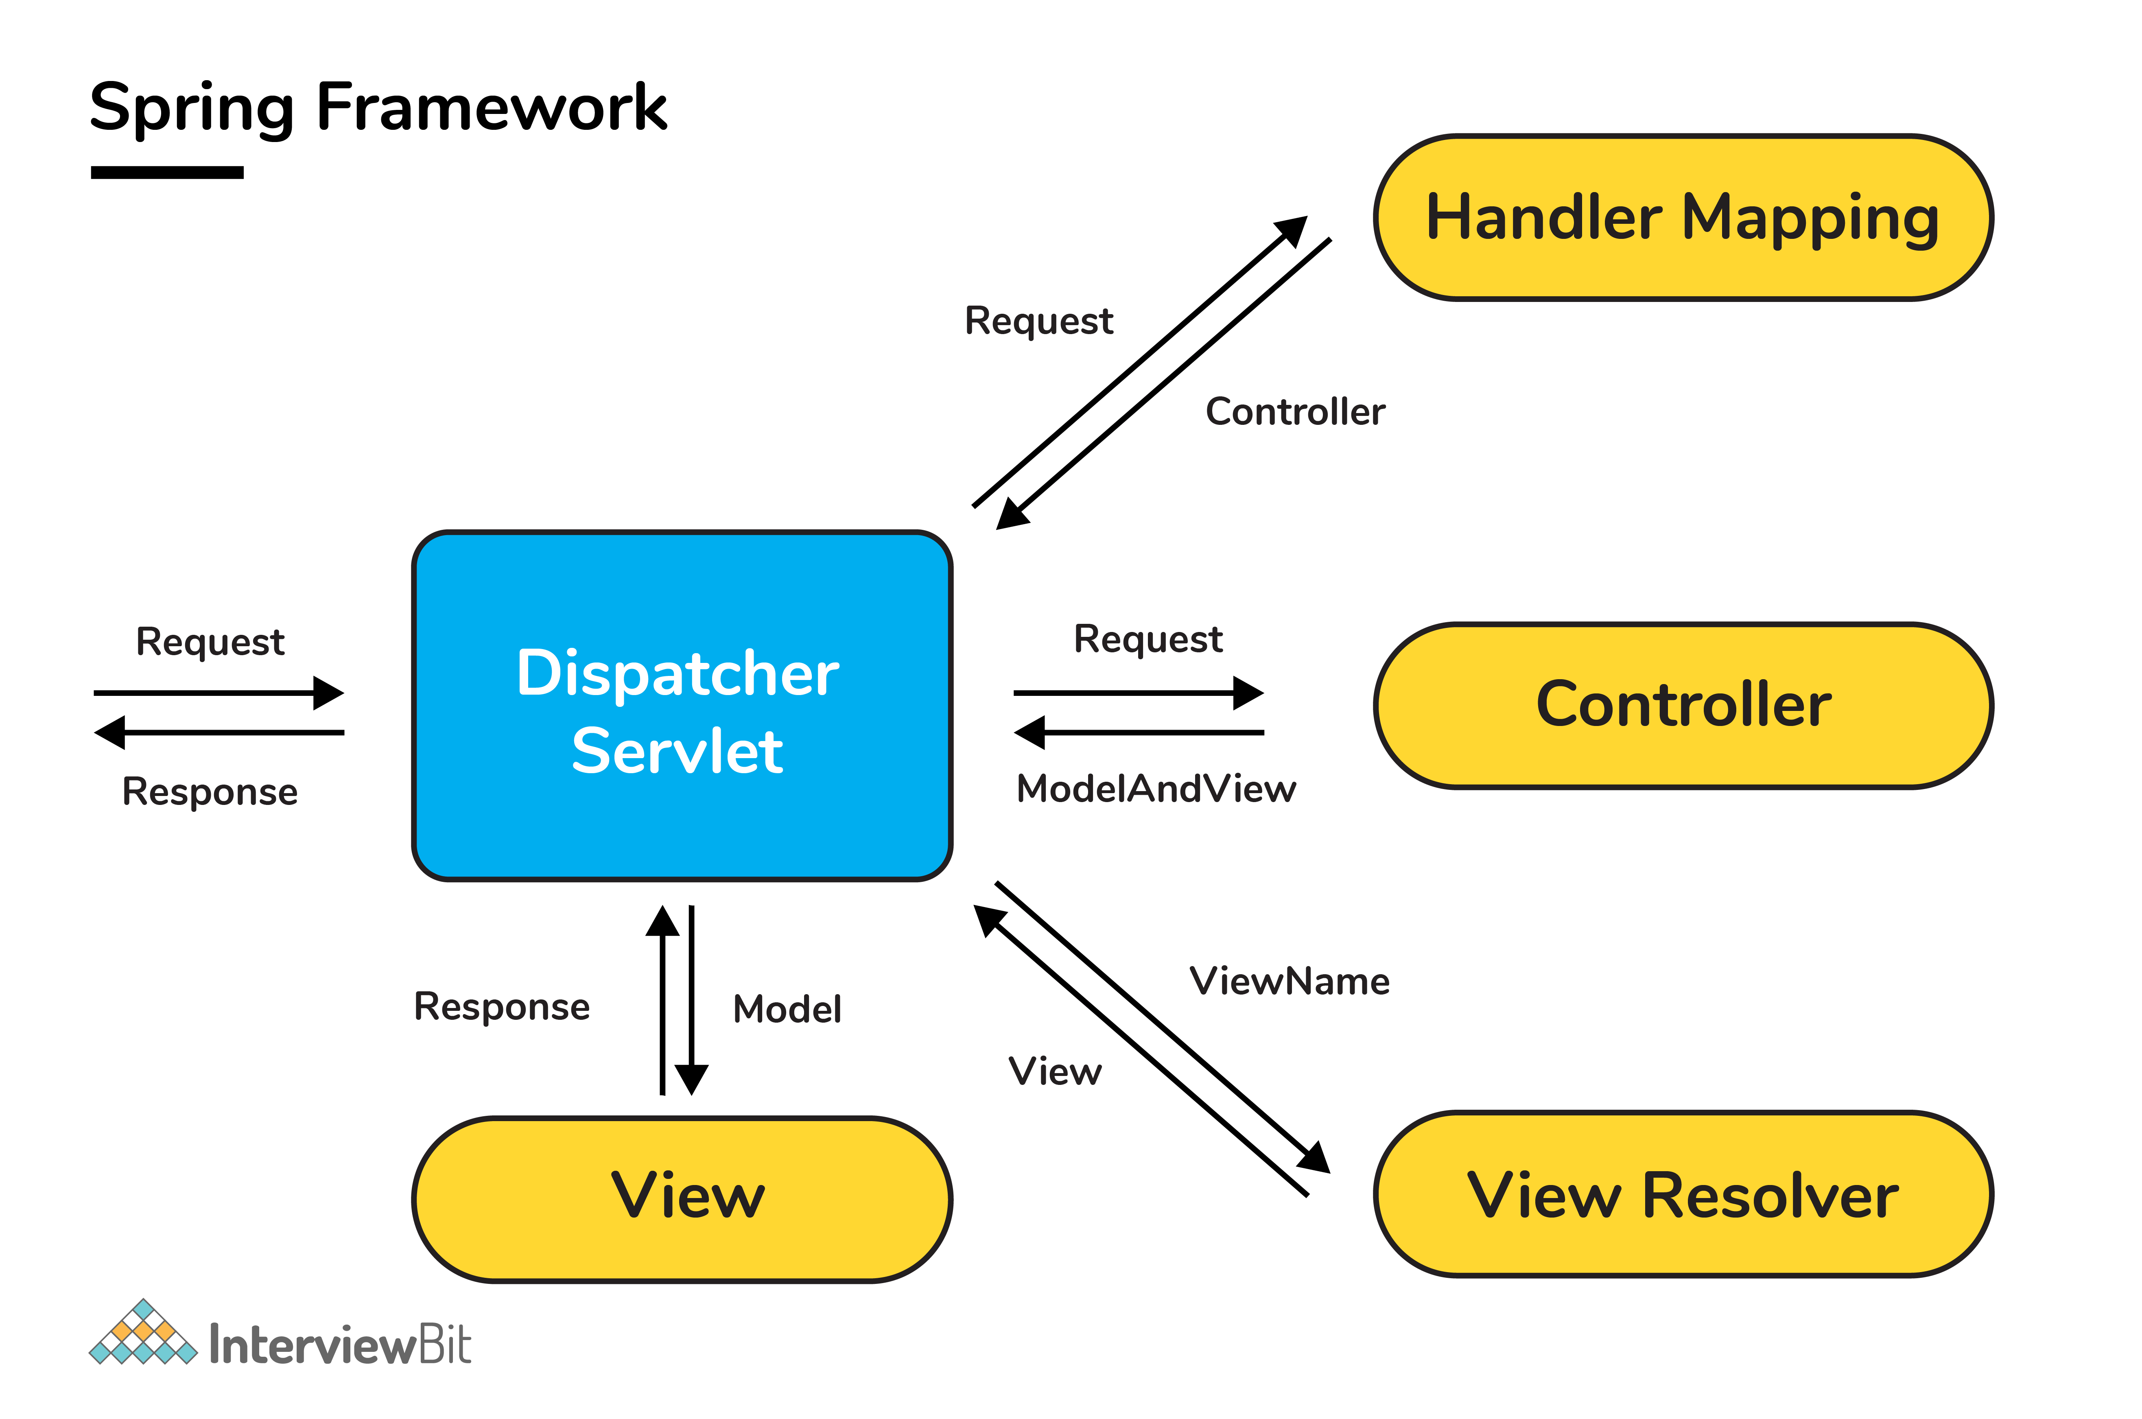

4. What is a View Resolver pattern and explain its significance in Spring MVC?
- It is a J2EE pattern which allows the applications to dynamically choose technology for rendering the data on the browser (View).
  - Any technology like HTML, JSP, XSLT, JSF, or any other such technology can be used as View.
- The View Resolver has the information of different views. The Controller returns the name of the View which is then passed to View Resolver by the DispatcherServlet for selecting the appropriate View technology and then the data is displayed.
- The default ViewResolver used in Spring MVC is InternalResourceViewResolver.

5. How is Validation supported in Spring MVC?
- Spring primarily supports two types of validations:
  - By using JSR-303 Annotations and any reference implementation, for example, Hibernate Validator.
  - Implementing org.springframework.validation.Validator interface and developing customizable validations.

6. What is the @Controller annotation used for?
- The @Controller is a stereotype Spring MVC annotation to define a Controller.

7. Can you create a controller without using @Controller or @RestController annotations?
- Yes! You can create a controller without @Controller or @RestController annotations by annotating the Spring MVC Controller classes using the @Component annotation. In this case, the real job of request mapping to handler method is done using the @RequestMapping annotation.

8. What is ContextLoaderListener and what does it do?
- The ContextLoaderListener loads and creates the ApplicationContext, so a developer need not write explicit code to do create it. In short, it is a listener that aids to bootstrap Spring MVC.
  - The application context is where Spring bean resides. For a web application, there is a subclass called WebAppliationContext.
- The lifecycle of the ApplicationContext is tied to the lifecycle of the ServletContext by using ContextLoaderListener. The ServletContext from the WebApplicationContext can be obtained using the getServletContext() method.

9. What are the differences between @RequestParam and @PathVariable annotations?
- Even though both these annotations are used to extract some data from URL, there is a key difference between them.
  - The @RequestParam is used to extract query parameters that is anything after "?" in the URL.
  - The @PathVariable is used to extract the data present as part of the URI itself.
  - Example, if the given URL is http://localhost:8080/InterviewBit/Spring/SpringMVC/?format=json, then you can access the query parameter "format" using the @RequestParam annotation and /Spring/{type} using the @PathVariable, which will give you SpringMVC.
  - @RequestMapping("/Spring/{type}")
  - public void getQuestions(@PathVariable("type") String type,
  - @RequestParam(value = "format", required = false) String format){
  - /* Some code */
  - }

10. What is the Model in Spring MVC?
- Model is a reference to have the data for rendering.
- It is always created and passed to the view in Spring MVC. If a mapped controller method has Model as parameter, then that model instance is automatically injected to that method.
- Any attributes set on the injected model would be preserved and passed to the View.

Spring AOP, Spring JDBC & Spring Hibernate

1. What is Spring AOP?
- Spring AOP (Aspect Oriented Programming) is similar to OOPs (Object Oriented Programming) as it also provides modularity.
- In AOP key unit is aspects or concerns which are nothing but stand-alone modules in the application. Some aspects have centralized code but other aspects may be scattered or tangled code like in the case of logging or transactions. These scattered aspects are called cross-cutting concern.
  - A cross-cutting concern such as transaction management, authentication, logging, security etc is a concern that could affect the whole application and should be centralized in one location in code as much as possible for security and modularity purposes.
- AOP provides platform to dynamically add these cross-cutting concerns before, after or around the actual logic by using simple pluggable configurations.
- This results in easy maintainenance of code. Concerns can be added or removed simply by modifying configuration files and therefore without the need for recompiling complete sourcecode.
- There are 2 types of implementing Spring AOP:
  - Using XML configuration files
  - Using AspectJ annotation style

2. What is an advice? Explain its types in spring.
- An advice is the implementation of cross-cutting concern can be applied on other modules of the spring application. Advices are of mainly 5 types :
  - Before :
    - This advice executes before a join point, but it does not have the ability to prevent execution flow proceeding to the join point (unless it throws an exception).
    - To use this, use @Before annotation.
  - AfterReturning :
    - This advice is to be executed after a join point completes normally i.e if a method returns without throwing an exception.
    - To use this, use @AfterReturning annotation.
  - AfterThrowing :
    - This advice is to be executed if a method exits by throwing an exception.
    - To use this, use @AfterThrowing annotation.
  - After :
    - This advice is to be executed regardless of the means by which a join point exits (normal return or exception encounter).
    - To use this, use @After annotation.
  - Around :
    - This is the most powerful advice surrounds a join point such as a method invocation.
    - To use this, use @Around annotation.

3. What is Spring AOP Proxy pattern?
- A proxy pattern is a well-used design pattern where a proxy is an object that looks like another object but adds special functionality to it behind the scenes.
- Spring AOP follows proxy-based pattern and this is created by the AOP framework to implement the aspect contracts in runtime.
- The standard JDK dynamic proxies are default AOP proxies that enables any interface(s) to be proxied. Spring AOP can also use CGLIB proxies that are required to proxy classes, rather than interfaces. In case a business object does not implement an interface, then CGLIB proxies are used by default.

4. What are some of the classes for Spring JDBC API?
- Following are the classes
  - JdbcTemplate
  - SimpleJdbcTemplate
  - NamedParameterJdbcTemplate
  - SimpleJdbcInsert
  - SimpleJdbcCall
- The most commonly used one is JdbcTemplate. This internally uses the JDBC API and has the advantage that we don't need to create connection, statement, start transaction,commit transaction and close connection to execute different queries. All these are handled by JdbcTemplate itself. The developer can focus on executing the query directly.

5. How can you fetch records by Spring JdbcTemplate?
- This can be done by using the query method of JdbcTemplate. There are two interfaces that helps to do this:
  - ResultSetExtractor:
    - It defines only one method extractData that accepts ResultSet instance as a parameter and returns the list.
    - Syntax: public T extractData(ResultSet rs) throws SQLException,DataAccessException;
  - RowMapper:
    - This is a enhanced version of ResultSetExtractor that saves a lot of code.
    - It allows to map a row of the relations with the instance of user-defined class.
    - It iterates the ResultSet internally and adds it into the result collection thereby saving lot of code to fetch records.

What are the important features of Spring 5?
Spring 5 is a major overhaul from Spring 4. Some of the important features are:
- Support for Java 8 and higher versions, so we can use lambda expressions.
- Support for Java EE7 and Servlet 4.0 specs.
- File operations are performed via NIO 2 streams now, a huge improvement if your app does a lot of file handling.
- Introduction of spring-jcl to streamline logging, earlier it was a mess due to no single point for logging purposes.
- Support for Kotlin, Lombok, Reactor 3.1 Flux, and Mono as well as RxJava.
- Spring WebFlux that brings reactive programming to Spring.
- Support for JUnit 5
- Support for providing spring components information through index file “META-INF/spring.components” rather than classpath scanning.
Please go through Spring 5 features to get a detailed overview of this release.

5. What is Spring WebFlux?
Spring WebFlux is the new module introduced in Spring 5. Spring WebFlux is the first step towards the reactive programming model in the spring framework.
Spring WebFlux is the alternative to the Spring MVC module. Spring WebFlux is used to create a fully asynchronous and non-blocking application built on the event-loop execution model.
You can read more about it at

What do you understand by Aspect-Oriented Programming?
Enterprise applications have some common cross-cutting concerns that are applicable to different types of Objects and application modules, such as logging, transaction management, data validation, authentication, etc. The modularity of application is achieved by classes in Object-oriented programming. In AOP, application modularity is achieved by Aspects and they are configured to cut across different class methods.
AOP takes out the direct dependency of cross-cutting tasks from classes that are not possible in normal object-oriented programming. For example, we can have a separate class for logging but the other classes will have to call these methods. But, in AOP we configure the aspects and method execution happens automatically. Read more about Spring AOP support at Spring AOP Example.

11. What is Aspect, Advice, Pointcut, JointPoint and Advice Arguments in AOP?
Aspect: Aspect is a class that implements cross-cutting concerns, such as transaction management. Aspects can be a normal class configured and then configured in the Spring Bean configuration file or we can use Spring AspectJ support to declare a class as an Aspect using @Aspect annotation.
Advice: Advice is the action taken for a particular join point. In terms of programming, they are methods that get executed when a specific join point with a matching pointcut is reached in the application. You can think of Advice as Spring interceptors or Servlet Filters.
Pointcut: Pointcuts are regular expressions that are matched with join points to determine whether advice needs to be executed or not. Pointcut uses different kinds of expressions that are matched with the join points. Spring framework uses the AspectJ pointcut expression language for determining the join points where advice methods will be applied.
JoinPoint: A join point is a specific point in the application such as method execution, exception handling, changing object variable values, etc. In Spring AOP a join point is always the execution of a method.
Advice Arguments: We can pass arguments in the advice methods. We can use the args() expression in the pointcut to be applied to any method that matches the argument pattern. If we use this, then we need to use the same name in the advice method from where the argument type is determined.
These concepts seem confusing at first, but if you go through Spring Aspect, Advice Example then you can easily relate to them.

What is the Spring Bean’s life cycle?
Spring Beans are initialized by Spring Container and all the dependencies are also injected. When the context is destroyed, it also destroys all the initialized beans. This works well in most cases but sometimes we want to initialize other resources or do some validation before making our beans ready to use. Spring framework provides support for post-initialization and pre-destroy methods in spring beans.
We can do this in two ways – by implementing InitializingBean and DisposableBean interfaces or using init-method and destroy-method attribute in spring bean configurations. For more details, please read Spring Bean Life Cycle Methods.
Spring Bean Lifecycle: Using Spring Aware Interfaces
When a bean implements an Aware interface, the Spring Framework injects a particular framework object to the bean through a callback-style method. The object Spring injects depends on the interface which the bean implements. For example, if the bean implements the ApplicationContextAware interface, Spring will inject an ApplicationContext object into the bean.
In this post, we will learn about the Spring aware interfaces, particularly ApplicationContextAware, BeanFactoryAware, and BeanNameAware interfaces.
In the bean lifecycle, the Spring Framework calls the aware interface methods after populating bean properties and just before pre initialization with BeanPostProcessor.

The ApplicationContextAware Interface
In Spring beans, you might require access to the ApplicationContext. For example, if your bean needs to look up some other beans. Similarly, if your bean needs access to some application file resource in your bean or even publish some application events, you need access to the ApplicationContext.
Spring provides an ApplicationContextAware interface that allows beans access to the ApplicationContext. This interface provides a single setApplicationContext method.
1
void setApplicationContext(ApplicationContext applicationContext)
2
throws BeansException

The following code shows the use of ApplicationContextAware.
1
6
public class ApplicationContextAwareImpl implements ApplicationContextAware {
7
@Override
8
public void setApplicationContext(ApplicationContext applicationContext) throws BeansException {
9
User user = (User) applicationContext.getBean("user");
10
System.out.println("User Id: " + user.getUserId() + " User Name :" + user.getName());
11
}
12
}
The preceding code is of a bean that implements ApplicationContextAware. The code overrides the setApplicationContext() method to lookup another bean with the id user using the injected ApplicationContext.

The BeanFactoryAware Interface
Beans might need access to the bean factory that created it, say to call any service from the bean factory.
Should you need to obtain a reference to the bean factory, implement the BeanFactoryAware interface. This interface provides the setBeanFactory() method.
1
void setBeanFactory(BeanFactory beanFactory)
The preceding setBeanFactory() is a callback that supplies the owning factory to the bean instance.
Here is an example of a bean that implements the BeanFactoryAware Interface.
public class BeanFactoryAwareImpl implements BeanFactoryAware {
6
@Override
7
public void setBeanFactory(BeanFactory beanFactory) throws BeansException {
8
System.out.println(beanFactory.getBean("user"));
9
}
10
}

The BeanNameAware Interface
The BeanNameAware interface is implemented by beans that need access to its name defined in the Spring container. This interface provides the setBeanName() method.
1
public void setBeanName(String beanName)
Here is an example of a bean which implements the BeanNameAware Interface.
5
public class BeanFactoryAwareImpl implements implements BeanNameAware {
@Override
public void setBeanName(String beanName)
{ System.out.println(beanName);

}
}

The difference between Spring's BeanFactoryPostProcessor and BeanPostProcessor
The user can process the bean of the initialization process by implementing two interfaces: BeanFactoryPostProcessor and BeanPostProcessor.

First, BeanFactoryPostProcessor
The interface source code is as follows:
public interface BeanFactoryPostProcessor {
/ / Can get the bean definition information through the beanFactory
void postProcessBeanFactory(ConfigurableListableBeanFactory beanFactory) throws BeansException; }
The BeanFactoryPostProcessor interface is for the bean container. Its implementation class can modify the bean's definition property before the bean is instantiated after the current BeanFactory is initialized (the spring container loads the bean definition file) to achieve the effect of instantiating the bean after the effect.
That is, Spring allows BeanFactoryPostProcessor to read configuration metadata before the container instantiates any other beans, and can modify it as needed. For example, you can change the scope of the bean from singleton to prototype. You can also modify the value of the property. You can configure multiple BeanFactoryPostProcessors at the same time and control the execution order of each BeanFactoryPostProcessor by setting the 'order' property.
Spring has some built-in BeanFactoryPostProcessor interface implementation classes, as shown below:

Second, BeanPostProcessor
The source code for this method is as follows:
public interface BeanPostProcessor {

//before calling before bean initialization
@Nullable
default Object postProcessBeforeInitialization(Object bean, String beanName) throws BeansException {
return bean;
}
//before calling after bean initialization
@Nullable
default Object postProcessAfterInitialization(Object bean, String beanName) throws BeansException {
return bean;
}
}
BeanPostProcessor can add some processing logic before and after executing the bean initialization method after the spring container instantiates the bean. The initialization method includes the following two types:
1, the bean that implements the InitializingBean interface, the corresponding method is afterPropertiesSet
2, xml definition, the method set by init-method
BeanPostProcessor is executed after BeanFactoryPostProcessor.
Spring has some built-in BeanPostProcessor interface implementation classes, as shown below:
The main difference is: BeanFactoryPostProcessor can modify the BEAN configuration information and BeanPostProcessor cannot, and give an example of an example Bean class: [java] view plain copy...

How to get ServletContext and ServletConfig object in a Spring Bean?
There are two ways to get Container specific objects in the spring bean.
- Implementing Spring *Aware interfaces, for these ServletContextAware and ServletConfigAware interfaces, for a complete example of these aware interfaces, please read Spring Aware Interfaces.
- Using @Autowired annotation with bean variable of type ServletContext and ServletConfig. They will work only in servlet container-specific environments only.
@Autowired
ServletContext servletContext;

- autowiring by @Autowired and @Qualifier annotations

Does Spring Bean provide thread safety?
The default scope of Spring bean is singleton, so there will be only one instance per context. That means that all the having a class level variable that any thread can update will lead to inconsistent data. Hence in default mode spring beans are not thread-safe.
However, we can change spring bean scope to request, prototype or session to achieve thread-safety at the cost of performance. It’s a design decision and based on the project requirements.

What’s the difference between @Component, @Controller, @Repository & @Service annotations in Spring?
@Component is used to indicate that a class is a component. These classes are used for auto-detection and configured as a bean when annotation-based configurations are used.
@Controller is a specific type of component, used in MVC applications and mostly used with RequestMapping annotation.
@Repository annotation is used to indicate that a component is used as a repository and a mechanism to store/retrieve/search data. We can apply this annotation with DAO pattern implementation classes.
@Service is used to indicate that a class is a Service. Usually, the business facade classes that provide some services are annotated with this.
We can use any of the above annotations for a class for auto-detection but different types are provided so that you can easily distinguish the purpose of the annotated classes.
https://stackoverflow.com/questions/6827752/whats-the-difference-between-component-repository-service-annotations-in

25. What is DispatcherServlet and ContextLoaderListener?
DispatcherServlet is the front controller in the Spring MVC application and it loads the spring bean configuration file and initializes all the beans that are configured. If annotations are enabled, it also scans the packages and configures any bean annotated with @Component, @Controller, @Repository, or @Service annotations.
ContextLoaderListener is the listener to start up and shut down Spring’s root WebApplicationContext. Its important functions are to tie up the lifecycle of ApplicationContext to the lifecycle of the ServletContext and to automate the creation of ApplicationContext. We can use it to define shared beans that can be used across different spring contexts.
<!-- Resolves views selected for rendering by @Controllers to .jsp resources in the /WEB-INF/views directory -->
<beans:bean class="org.springframework.web.servlet.view.InternalResourceViewResolver">
<beans:property name="prefix" value="/WEB-INF/views/" />
<beans:property name="suffix" value=".jsp" />
</beans:bean>

How to handle exceptions in Spring MVC Framework?
Spring MVC Framework provides the following ways to help us achieving robust exception handling.
@ControllerAdvice
31
public class ExceptionHelper {
32
33
private static final Logger logger = LoggerFactory.getLogger(ExceptionHelper.class);
34

35
@ExceptionHandler(value = { InvalidInputException.class })
36
public ResponseEntity<Object> handleInvalidInputException(InvalidInputException ex) {
37
LOGGER.error("Invalid Input Exception: ",ex.getMessage());
38
return new ResponseEntity<Object>(ex.getMessage(),HttpStatus.BAD_REQUEST);
39
}
40

41
@ExceptionHandler(value = { Unauthorized.class })
42
public ResponseEntity<Object> handleUnauthorizedException(Unauthorized ex) {
43
LOGGER.error("Unauthorized Exception: ",ex.getMessage());
44
return new ResponseEntity<Object>(ex.getMessage(),HttpStatus.BAD_REQUEST);
45
}
46

47
@ExceptionHandler(value = { BusinessException.class })
48
public ResponseEntity<Object> handleBusinessException(BusinessException ex) {
49
LOGGER.error("Business Exception: ",ex.getMessage());
50
return new ResponseEntity<Object>(ex.getMessage(),HttpStatus.INTERNAL_SERVER_ERROR);
51
}
52

53
@ExceptionHandler(value = { Exception.class })
54
public ResponseEntity<Object> handleException(Exception ex) {
55
LOGGER.error("Exception: ",ex.getMessage());
56
return new ResponseEntity<Object>(ex.getMessage(),HttpStatus.INTERNAL_SERVER_ERROR);
57
}
58
}

Controller-Based – We can define exception handler methods in our controller classes. All we need is to annotate these methods with @ExceptionHandler annotation.
Global Exception Handler – Exception Handling is a cross-cutting concern and Spring provides @ControllerAdvice annotation that we can use with any class to define our global exception handler.
HandlerExceptionResolver implementation – For generic exceptions, most of the time we serve static pages. Spring Framework provides a HandlerExceptionResolver interface that we can implement to create a global exception handler. The reason behind this additional way to define the global exception handler is that the Spring framework also provides default implementation classes that we can define in our spring bean configuration file to get spring framework exception handling benefits.
For a complete example, please read Spring Exception Handling Example.

29. How to create ApplicationContext in a Java Program?
There are following ways to create spring context in a standalone java program.
- AnnotationConfigApplicationContext: If we are using Spring in standalone Java applications and using annotations for Configuration, then we can use this to initialize the container and get the bean objects.
- ClassPathXmlApplicationContext: If we have a spring bean configuration XML file in a standalone application, then we can use this class to load the file and get the container object.
- FileSystemXmlApplicationContext: This is similar to ClassPathXmlApplicationContext except that the XML configuration file can be loaded from anywhere in the file system.

Can we have multiple Spring configuration files?
For Spring MVC applications, we can define multiple spring context configuration files through contextConfigLocation. This location string can consist of multiple locations separated by any number of commas and spaces. For example;
<servlet>
<servlet-name>appServlet</servlet-name>
<servlet-class>org.springframework.web.servlet.DispatcherServlet</servlet-class>
<init-param>
<param-name>contextConfigLocation</param-name>
<param-value>/WEB-INF/spring/appServlet/servlet-context.xml,/WEB-INF/spring/appServlet/servlet-jdbc.xml</param-value>
</init-param>
<load-on-startup>1</load-on-startup>
</servlet>
We can also define multiple root level spring configurations and load it through context-param. For example;
<context-param>
<param-name>contextConfigLocation</param-name>
<param-value>/WEB-INF/spring/root-context.xml /WEB-INF/spring/root-security.xml</param-value>
</context-param>
Another option is to use import element in the context configuration file to import other configurations, for example:
<beans:import resource="spring-jdbc.xml"/>
ContextLoaderListener is the listener class used to load root context and define spring bean configurations that will be visible to all other contexts. It’s configured in web.xml file as:
<context-param>
<param-name>contextConfigLocation</param-name>
<param-value>/WEB-INF/spring/root-context.xml</param-value>
</context-param>

<listener>
<listener-class>org.springframework.web.context.ContextLoaderListener</listener-class>
</listener>

What are some of the important Spring annotations you have used?
Some of the Spring annotations that I have used in my project are:
- @Controller – for controller classes in Spring MVC project.
- @RequestMapping – for configuring URI mapping in controller handler methods. This is a very important annotation, so you should go through Spring MVC RequestMapping Annotation Examples
- @ResponseBody – for sending Object as a response, usually for sending XML or JSON data as a response.
- @PathVariable – for mapping dynamic values from the URI to handler method arguments.
- @Autowired – for auto wiring dependencies in spring beans.
- @Qualifier – with @Autowired annotation to avoid confusion when multiple instances of bean type are present.
- @Service – for service classes.
- @Scope – for configuring scope of the spring bean.
- @Configuration, @ComponentScan, and @Bean – for java based configurations.
- AspectJ annotations for configuring aspects and advice, @Aspect, @Before, @After, @Around, @Pointcut, etc.

What is Spring MVC Interceptor and how to use it?
Spring MVC Interceptors are like Servlet Filters and allow us to intercept client requests and process them. We can intercept client requests at three places – preHandle, postHandle, and afterCompletion.
We can create a spring interceptor by implementing the HandlerInterceptor interface or by extending the abstract class HandlerInterceptorAdapter.
We need to configure interceptors in the spring bean configuration file. We can define an interceptor to intercept all the client requests or we can configure it for specific URI mapping too. For a detailed example, please refer Spring MVC Interceptor Example.

How would you achieve Transaction Management in Spring?
Spring framework provides transaction management support through Declarative Transaction Management as well as programmatic transaction management. Declarative transaction management is most widely used because it’s easy to use and works in most of the cases.
We use annotate a method with @Transactional annotation for Declarative transaction management. We need to configure the transaction manager for the DataSource in the spring bean configuration file.
<bean id="transactionManager"
class="org.springframework.jdbc.datasource.DataSourceTransactionManager">
<property name="dataSource" ref="dataSource" />
</bean>

How to inject a java.util.Properties into a Spring Bean?
We have to define the propertyConfigurer bean that will load the properties from the given property file. Then we can use Spring EL support to inject properties into other bean dependencies. For example:
<bean id="propertyConfigurer"
class="org.springframework.context.support.PropertySourcesPlaceholderConfigurer">
<property name="location" value="/WEB-INF/application.properties" />
</bean>

<bean class="com.journaldev.spring.EmployeeDaoImpl">
<property name="maxReadResults" value="${results.read.max}"/>
</bean>
If you are using annotation to configure the spring bean, then you can inject property like below.
@Value("${maxReadResults}")
private int maxReadResults;

How to integrate spring and hibernate xml based
- <bean id="dataSource" class="org.apache.commons.dbcp.BasicDataSource">
- <property name="driverClassName" value="oracle.jdbc.driver.OracleDriver"></property>
- <property name="url" value="jdbc:oracle:thin:@localhost:1521:xe"></property>
- <property name="username" value="system"></property>
- <property name="password" value="oracle"></property>
- </bean>

- <bean id="mysessionFactory" class="org.springframework.orm.hibernate3.LocalSessionFactoryBean">
- <property name="dataSource" ref="dataSource"></property>

- <property name="mappingResources">
- <list>
- <value>employee.hbm.xml</value>
- </list>
- </property>

- <property name="hibernateProperties">
- <props>
- <prop key="hibernate.dialect">org.hibernate.dialect.Oracle9Dialect</prop>
- <prop key="hibernate.hbm2ddl.auto">update</prop>
- <prop key="hibernate.show_sql">true</prop>

- </props>
- </property>
- </bean>

- <bean id="template" class="org.springframework.orm.hibernate3.HibernateTemplate">
- <property name="sessionFactory" ref="mysessionFactory"></property>
- </bean>

- <bean id="d" class="com.javatpoint.EmployeeDao">
- <property name="template" ref="template"></property>
- </bean>

- </beans>

- public class EmployeeDao {
- HibernateTemplate template;
- public void setTemplate(HibernateTemplate template) {
- this.template = template;
- }
- //method to save employee
- public void saveEmployee(Employee e){
- template.save(e);
- }
}

Now integrate spring with MongoDB

MongoTemplate and MongoRepository
The MongoTemplate follows the standard template pattern in Spring and provides a ready to go, basic API to the underlying persistence engine.
The repository follows the Spring Data-centric approach and comes with more flexible and complex API operations, based on the well-known access patterns in all Spring Data projects.
For both, we need to start by defining the dependency – for example, in the pom.xml, with Maven:
<dependency>
<groupId>org.springframework.data</groupId>
<artifactId>spring-data-mongodb</artifactId>
<version>3.0.3.RELEASE</version>
</dependency>

Configuration for MongoTemplate

3.1. XML Configuration
Let’s start with the simple XML configuration for the Mongo template:
<mongo:mongo-client id="mongoClient" host="localhost" />
<mongo:db-factory id="mongoDbFactory" dbname="test" mongo-client-ref="mongoClient" />
First, we need to define the factory bean responsible for creating Mongo instances.
Next – we need to actually define (and configure) the template bean:
<bean id="mongoTemplate" class="org.springframework.data.mongodb.core.MongoTemplate">
<constructor-arg ref="mongoDbFactory"/>
</bean>
And finally, we need to define a post processor to translate any MongoExceptions thrown in @Repository annotated classes:
<bean class=
"org.springframework.dao.annotation.PersistenceExceptionTranslationPostProcessor"/>

3.2. Java Configuration
Let’s now create a similar configuration using Java config by extending the base class for MongoDB configuration AbstractMongoConfiguration:
@Configuration
public class MongoConfig extends AbstractMongoClientConfiguration {

@Override
protected String getDatabaseName() {
return "test";
}

@Override
public MongoClient mongoClient() {
ConnectionString connectionString = new ConnectionString("mongodb://localhost:27017/test");
MongoClientSettings mongoClientSettings = MongoClientSettings.builder()
.applyConnectionString(connectionString)
.build();

return MongoClients.create(mongoClientSettings);
}

@Override
public Collection getMappingBasePackages() {
return Collections.singleton("com.baeldung");
}
}
Note: We didn't need to define MongoTemplate bean in the previous configuration as it's already defined in AbstractMongoClientConfiguration.
We can also use our configuration from scratch without extending AbstractMongoClientConfiguration – as follows:
@Configuration
public class SimpleMongoConfig {

@Bean
public MongoClient mongo() {
ConnectionString connectionString = new ConnectionString("mongodb://localhost:27017/test");
MongoClientSettings mongoClientSettings = MongoClientSettings.builder()
.applyConnectionString(connectionString)
.build();

return MongoClients.create(mongoClientSettings);
}

@Bean
public MongoTemplate mongoTemplate() throws Exception {
return new MongoTemplate(mongo(), "test");
}
}

4. Configuration for MongoRepository

4.1. XML Configuration
To make use of custom repositories (extending the MongoRepository) – we need to continue the configuration from section 3.1 and set up the repositories:
<mongo:repositories
base-package="com.baeldung.repository" mongo-template-ref="mongoTemplate"/>

4.2. Java Configuration
Similarly, we'll build on the configuration we already created in section 3.2 and add a new annotation into the mix:
@EnableMongoRepositories(basePackages = "com.baeldung.repository")

4.3. Create the Repository
Now, after the configuration, we need to create a repository – extending the existing MongoRepository interface:
public interface UserRepository extends MongoRepository<User, String> {
//
}
Now we can auto-wire this UserRepository and use operations from MongoRepository or add custom operations.

5. Using MongoTemplate

5.1. Insert
Let's start with the insert operation; let's also start with an empty database:
{
}
Now if we insert a new user:
User user = new User();
user.setName("Jon");
mongoTemplate.insert(user, "user");
The database will look like this:
{
"_id" : ObjectId("55b4fda5830b550a8c2ca25a"),
"_class" : "com.baeldung.model.User",
"name" : "Jon"
}

5.2. Save – Insert
The save operation has save-or-update semantics: if an id is present, it performs an update, if not – it does an insert.
Let's look at the first semantic – the insert; here's the initial state of the database:
{
}
When we now save a new user:
User user = new User();
user.setName("Albert");
mongoTemplate.save(user, "user");
The entity will be inserted in the database:
{
"_id" : ObjectId("55b52bb7830b8c9b544b6ad5"),
"_class" : "com.baeldung.model.User",
"name" : "Albert"
}
Next, we'll look at the same operation – save – with update semantics.

5.3. Save – Update
Let's now look at save with update semantics, operating on an existing entity:
{
"_id" : ObjectId("55b52bb7830b8c9b544b6ad5"),
"_class" : "com.baeldung.model.User",
"name" : "Jack"
}
Now, when we save the existing user – we will update it:
user = mongoTemplate.findOne(
Query.query(Criteria.where("name").is("Jack")), User.class);
user.setName("Jim");
mongoTemplate.save(user, "user");

When we now run the updateFirst:
Query query = new Query();
query.addCriteria(Criteria.where("name").is("Alex"));
Update update = new Update();
update.set("name", "James");
mongoTemplate.updateFirst(query, update, User.class);

Now, let's now run the updateMulti operation:
Query query = new Query();
query.addCriteria(Criteria.where("name").is("Eugen"));
Update update = new Update();
update.set("name", "Victor");
mongoTemplate.updateMulti(query, update, User.class);

Let's look at the actual operation code:
Query query = new Query();
query.addCriteria(Criteria.where("name").is("Markus"));
Update update = new Update();
update.set("name", "Nick");
User user = mongoTemplate.findAndModify(query, update, User.class);

Now – let's run the upsert:
Query query = new Query();
query.addCriteria(Criteria.where("name").is("Markus"));
Update update = new Update();
update.set("name", "Nick");
mongoTemplate.upsert(query, update, User.class);

Let's now run remove:
mongoTemplate.remove(user, "user");

Using MongoRepository

6.1. Insert
First – the state of the database before running the insert:
{
}
Now, when we insert a new user:
User user = new User();
user.setName("Jon");
userRepository.insert(user);
Here's the end state of the database:
{
"_id" : ObjectId("55b4fda5830b550a8c2ca25a"),
"_class" : "com.baeldung.model.User",
"name" : "Jon"
}
Note how the operation works the same as the insert in the MongoTemplate API.

6.2. Save – Insert
Similarly – save works the same as the save operation in the MongoTemplate API.
Let's start by looking at the insert semantics of the operation; here's the initial state of the database:
{
}
Now – we execute the save operation:
User user = new User();
user.setName("Aaron");
userRepository.save(user);
This results in the user being added to the database:
{
"_id" : ObjectId("55b52bb7830b8c9b544b6ad5"),
"_class" : "com.baeldung.model.User",
"name" : "Aaron"
}
Note again how, in this example, save works with insert semantics, because we are inserting a new object.

6.3. Save – Update
Let's now look at the same operation but with update semantics.
First – here's the state of the database before running the new save:
{
"_id" : ObjectId("55b52bb7830b8c9b544b6ad5"),
"_class" : "com.baeldung.model.User",
"name" : "Jack"81*6
}
Now – we execute the operation:
user = mongoTemplate.findOne(
Query.query(Criteria.where("name").is("Jack")), User.class);
user.setName("Jim");
userRepository.save(user);
Finally, here is the state of the database:
{
"_id" : ObjectId("55b52bb7830b8c9b544b6ad5"),
"_class" : "com.baeldung.model.User",
"name" : "Jim"
}
Note again how, in this example, save works with update semantics, because we are using an existing object.

6.4. Delete
The state of the database before calling delete:
{
"_id" : ObjectId("55b5ffa5511fee0e45ed614b"),
"_class" : "com.baeldung.model.User",
"name" : "Benn"
}
Let's run delete:
userRepository.delete(user);
The result will simply be:
{
}

6.5. FindOne
The state of the database when findOne is called:
{
"_id" : ObjectId("55b5ffa5511fee0e45ed614b"),
"_class" : "com.baeldung.model.User",
"name" : "Chris"
}
Let's now execute the findOne:
userRepository.findOne(user.getId())
The result which will return the existing data:
{
"_id" : ObjectId("55b5ffa5511fee0e45ed614b"),
"_class" : "com.baeldung.model.User",
"name" : "Chris"
}

Now, let's run exists:
boolean isExists = userRepository.exists(user.getId());

List<User> users = userRepository.findAll(Sort.by(Sort.Direction.ASC, "name"));

Pageable pageableRequest = PageRequest.of(0, 1); Page<User> page = userRepository.findAll(pageableRequest); List<User> users = pages.getContent();

@Document("Employee")
public class Employee {

@Id
private String empId;
private String name;
private int age;
private double salary;

//getters and setters

What are you using PDF generation in spring –
<dependency>
<groupId>com.itextpdf</groupId>
<artifactId>itextpdf</artifactId>
<version>5.5.10</version>

</dependency>

<dependency>
<groupId>org.apache.pdfbox</groupId>
<artifactId>pdfbox</artifactId>
<version>2.0.4</version>
</dependency>

import com.itextpdf.html2pdf.ConverterProperties;
import com.itextpdf.html2pdf.HtmlConverter;
import com.itextpdf.html2pdf.resolver.font.DefaultFontProvider;
import com.itextpdf.io.font.FontProgram;
import com.itextpdf.io.font.FontProgramFactory;
import com.itextpdf.layout.font.FontProvider;
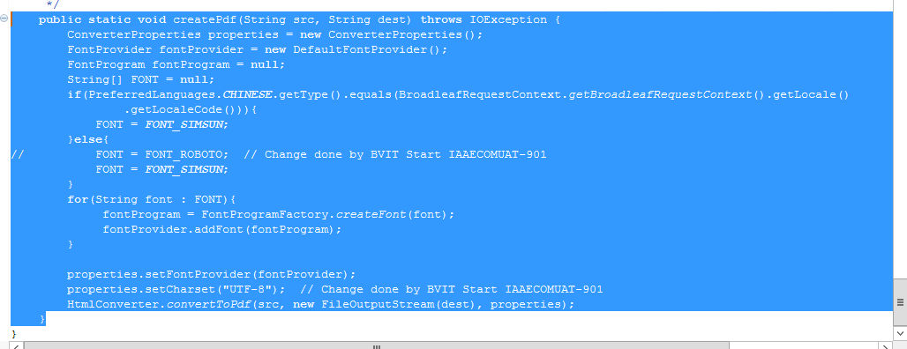

@RequestMapping(value = "/prePaymentInvoiceDownload/{orderName}"+"_PrepaymentInvoice" ,produces = "application/json; charset=UTF-8")
@PreAuthorize("@bvOrderSecurityService.hasPermissionToModifyOrder(#orderName, principal.username)")
//Added @PreAuthorize - protect logged in user to access the order details of other users -khem
public void prePaymentInvoiceGenerate(HttpServletRequest request, HttpServletResponse response, Model model,
@PathVariable("orderName") String orderName ,@RequestParam(name="approve" ,defaultValue="false",required=false) String approve) {
try {
generatePrePaymentInvoice(request,orderName,approve);

} catch (Exception e) {
}
ArrayList<String> paymentPdfPathList = (ArrayList<String>) request.getSession().getAttribute("paymentPdfPathList");
if (null != orderName) {
if (null != paymentPdfPathList && !(paymentPdfPathList.isEmpty())) {
for (String paymentPdfPath : paymentPdfPathList) {
if (null != Paths.get(paymentPdfPath)) {
response.setContentType("application/pdf");
String fileName = Paths.get(paymentPdfPath).getFileName().toString();
if (StringUtils.containsIgnoreCase(fileName, orderName)) {
response.addHeader("Content-Disposition", "inline; filename=" + fileName);
try {
Files.copy(Paths.get(Paths.get(paymentPdfPath).getParent().toString(),fileName), response.getOutputStream());/*Paths.get(paymentPdfPath).getParent().toString(),*/
response.getOutputStream().flush();
} catch (IOException e) {
logger.error("Exception in prePaymentInvoiceGenerate method : " + e.getMessage());
}
try {
Files.deleteIfExists(Paths.get(Paths.get(paymentPdfPath).getParent().toString(),fileName));
} catch (IOException e) {
logger.error("Exception in Deleting the Invoice : "+Paths.get(Paths.get(paymentPdfPath).getParent().toString(),fileName));
logger.error(e.getMessage());
}
}
}
}
}public String createPdf(String templatePath,String templateName, Map<String,Object> map) throws Exception {
logger.info(":::::::createPdf::::"+templatePath);
File outputFile=null;
String delimiter = "/";
String path = MessageConstants.PAYMENT_INVOICE_LOCATION;

Assert.notNull(templateName, "The templateName can not be null");
Context ctx = new Context();
if (map != null) {
Iterator<Entry<String, Object>> itMap = map.entrySet().iterator();
while (itMap.hasNext()) {
Map.Entry pair = (Map.Entry) itMap.next();
ctx.setVariable(pair.getKey().toString(), pair.getValue());
}
}

StringBuffer directory = new StringBuffer();
directory.append(path);
File dir = new File(directory.toString());
FileUtils.forceMkdir(dir);
directory.append(delimiter);
if(PreferredLanguages.CHINESE.getType().equals(BroadleafRequestContext.getBroadleafRequestContext().getLocale().getLocaleCode())){
ctx.setLocale(java.util.Locale.CHINESE);
}
String processedHtml = templateEngine.process(templatePath, ctx);
try {
outputFile = new File(directory + templateName + ".pdf");
while (outputFile.exists() && !outputFile.isDirectory()) {
outputFile = new File(directory + templateName + "(" + count + ")" + ".pdf");
count++;
}
filePath = outputFile.toString();
createPdf(processedHtml, outputFile.toString());
}catch(Exception e){
logger.info("exception in the catch block of pdf generator util class::",e);
}
logger.info(":::::::End createPdf::::"+filePath);
return filePath;
}
}
}

What are you using for reading and creating excel

org.apache.poi.ss.usermodel.Sheet;
import org.apache.poi.ss.usermodel.Workbook;
import org.apache.poi.ss.usermodel.WorkbookFactory;

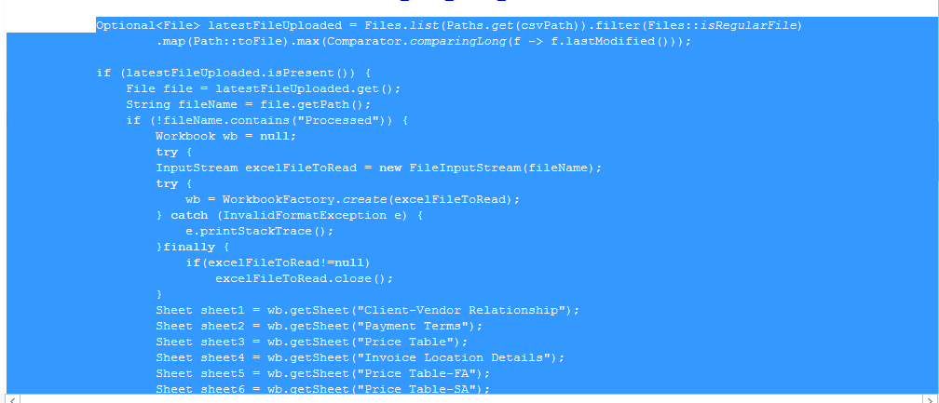
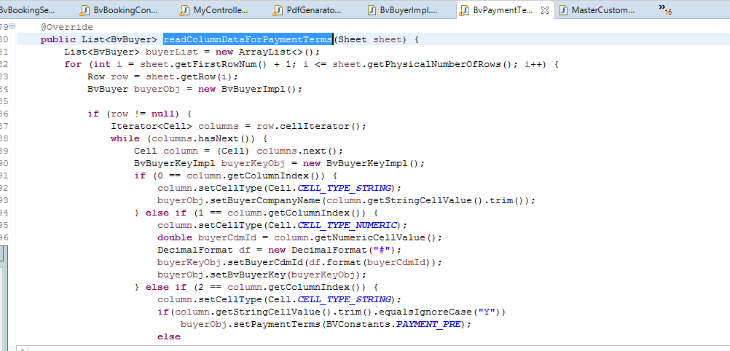
Ask Question

